CITY College

University of York Europe Campus

Computer Science Department

NAO as a Service Robot: An Intelligent Assistive Humanoid for Elderly Home Care

This report is submitted in partial fulfilment of the requirement for the degree of

Bachelor of Science with Honours in Computer Science by

Ada Urbina Merino

June 2026

NAO as a Service Robot: An Intelligent Assistive Humanoid for Elderly Home Care

by

Ada Urbina Merino

Supervisor: Dr Dimopoulos

ABSTRACT

This dissertation investigates whether generative artificial intelligence can be combined with assistive robotics to produce a system genuinely useful to elderly people living at home. Motivated by an ageing population and a widening gap between the demand for care and the carers available to provide it, the project designs and builds an intelligent assistive humanoid on the NAO platform within the Webots simulator. The system unites natural spoken conversation with practical assistance: it recognises and remembers its user, holds open-ended dialogue, issues medication reminders, offers companionship, and escorts the user between rooms after confirming where they are. Its guiding principle is a strict separation of concerns, a probabilistic language model is confined to interpreting language and conversing, while deterministic logic governs all movement and safety-critical action. Indoor navigation reasons over named rooms through a hierarchical planner and crosses doorways under explicit, inspectable control. Evaluation in simulation shows that the conversational and assistive behaviours succeed well, while physical navigation, doorway crossing above all, proves the hardest to make reliable and is the main source of failure. The work demonstrates a workable pattern for safe, conversational domestic assistance, and identifies perception, manipulation, and real-world hardware testing as the key steps toward deployment.

ACKNOWLEDGMENTS

DECLARATION

All sentences or passages quoted in this dissertation from other people’s work have been specifically acknowledged by clear cross-referencing to author, work and page(s). I understand that failure to do this, amounts to plagiarism and will be considered grounds for failure in this dissertation and the degree examination as a whole.

I have completed and submitted this work by myself without assistance from or communication with another person, either external or fellow student, or any AI type of content generator. I understand that not working on my own will be considered grounds for unfair means and will result in a fail mark for this work and might invoke disciplinary actions.
□ I agree that my dissertation can be used as a model/example by future students, for educational purposes only.

Name (block capitals): ............................................................................................................
Signed: ............................................................................. Date: ..............................................

Content table

Chapter 1 — Problem Description and Motivation 6

Chapter 2 — Background Research 9

2.1 The Global Ageing Population 9

2.2 Challenges Faced by Elderly People 10

2.3 Assistive Robotics 11

2.4 Human-Robot Interaction 12

2.5 Artificial Intelligence and Large Language Models 12

2.6 Indoor Navigation and Assistive Autonomy 13

2.7 Existing Assistive Robotic Systems and Related Work 14

2.8 Research Gap and Motivation for This Project 15

Chapter 3 — Project Vision and Planning 16

3.1 Vision of the Project 17

3.2 An AI-Centred Design Philosophy 17

3.3 The Choice of Webots and NAO 18

3.4 The Real Software Architecture 19

3.5 The AI Integration Strategy 20

3.6 Navigation and Assistive Planning Philosophy 21

3.7 Development Methodology and Iterative Planning 22

3.8 Project Planning and Implementation Stages 22

3.9 Critical Analysis of the Architectural Decisions 23

Chapter 4 — Project Implementation 23

4.1 Introduction to the Implementation 23

4.2 Overall System Implementation 24

4.3 Conversational AI Implementation 24

4.4 Voice Interaction and Communication Systems 25

4.5 Navigation System Implementation 26

4.6 Assistive Task Implementation 27

4.7 Environment Interaction 28

4.8 Iterative Development Process 28

4.9 Testing and Debugging 29

4.10 Requirement Analysis and Implementation Evaluation 29

4.11 Critical Technical Analysis 30

Chapter 5 — Evaluation and Critical Reflection 31

5.1 Introduction to the Evaluation 31

5.2 Evaluation of the Original Objectives 31

5.3 Evaluation of the AI Systems 32

5.4 Evaluation of Navigation and Assistive Behaviour 32

5.5 Evaluation of the Architecture and Implementation 33

5.6 Testing and Iterative Improvement Analysis 34

5.7 Limitations of the Current System 34

5.8 Societal and Ethical Reflection 35

5.9 Personal and Technical Reflection 35

Chapter 6 — Conclusion and Future Work 36

6.1 Overall Project Summary 36

6.2 Summary of Achievements 36

6.3 Contribution of the Project 36

6.4 Critical Reflection 37

6.5 Societal Impact and Future Relevance 37

6.6 Future Work 37

6.7 Concluding Reflection 39

References 41

List of Figures

Figure 1.1 Ageing population line chart

Figure 3.1 NAO robot

Figure 3.2 RobotBrain state machine

Figure 4.1 Upper view of house layout

Figure 4.2 Side view of house layout

Figure 4.3 System architecture

Figure 4.4 Conversational pipeline

Figure 4.5 Navigation layers diagram

Figure 4.6 Door-opening sequence

List of Tables

Table 2.1 Comparison of PARO, Pepper, Care-O-bot and HSR

Table 6.1 Requirements success summary

Chapter 1 — Problem Description and Motivation
The phenomenon of world wide ageing has transformed a characteristic feature of humanity into a significant modern social issue. Extended life span combined with falling fertility rates in both developing and developed areas is causing an unprecedented rise in the proportion of seniors among the world's population, something for which our current system of elderly care is ill-equipped to handle [1], [2] (see Figure 1.1). This chapter outlines the issue that will become the focus of the dissertation research: the issues faced by elderly people with reduced mobility or cognitive impairment in completing tasks at home. It will be shown throughout this dissertation that the use of intelligent robots is a feasible solution to this issue.
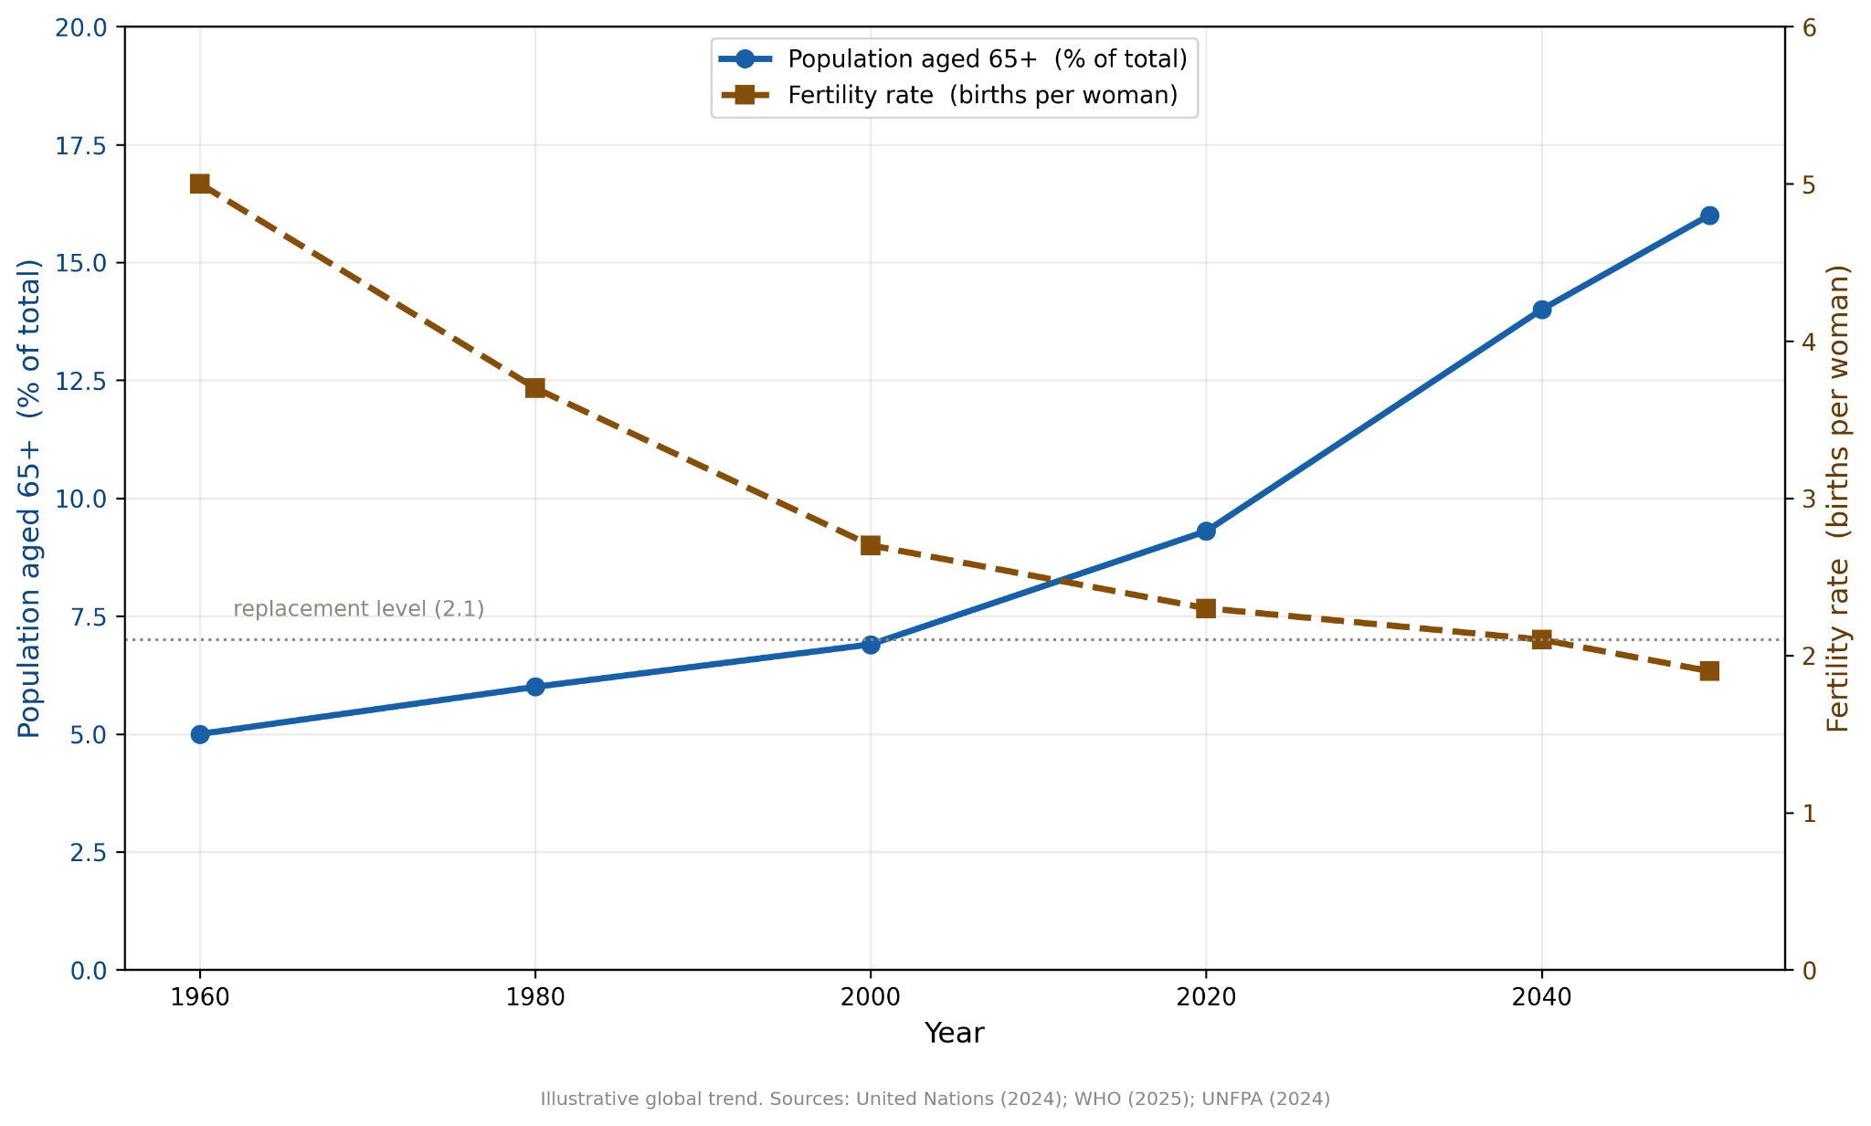

Figure 1.1 Ageing population line chart
The domestic environment is usually a place that offers comfort due to familiarity. However, it fails to address many problems related to the effects of ageing. Simple chores, such as moving between different rooms, reaching for objects that are spread throughout the house, and sticking to the schedule for taking medication may prove difficult and dangerous. Fall accidents are very common among older patients because they occur while the patient moves from one room to another. In addition, as individuals age, they experience cognitive challenges, such as forgetting things.
Several underlying reasons give rise to the need for a mandate of home health care services. Weaknesses and lack of flexibility make an individual unable to undertake his/her responsibilities at home. Besides, mental disabilities and lack of focus make it difficult for them to adhere to treatment programs because they have to be supervised carefully to make sure that they take their medication at the right time. Additionally, there are emotional repercussions due to lack of socialization, which makes one feel lonely, especially when one is either a widow or living far away from family members.
Another factor adding to the problem is the fact that in many societies today, the number of elderly persons is equivalent to the number of people working. The parity of these numbers makes previous assumptions about caregivers for the elderly invalid [3]–[5]. Health care and social care systems find themselves under increasing pressure, which results in lengthy waiting times.
Caring of elderly people or impaired people is twofold: The physical support to help them with mobility aspects or chores completion and the human touch in the form of emotional support to cope with loneliness.
The use of assistive technology aims to implement the human capital without replacing them. When properly designed, assistive technologies help the caregiver in the physical tasks allowing him/her to focus on the human aspects of care.
With this as a motivation, the goal of this project is then described as:
This project is intended to assist the elderly and disabled to do tasks at home through simple manipulations using an integrated artificial intelligence system and assistive robotic platform like Webots. The projects concentrate on simulating the tasks in the robot’s home environment for example navigation, interaction, notification and general home caring using the robot.
To achieve this aim, the project is guided by the following objectives:
- To create intuitive, non-technical interactions between the user and the robot, enabling elderly people to speak in natural commands to the system, not use complex technical input.
- To develop an extendible and configurable system which can be customized to suit individual house plans and expanded to include many domestic tasks.
- To investigate the extent to which AI will enhance the robotic assistant's behaviour in terms of user interaction, command interpretation and the coordination of a simple support function in a simulated domestic setting.
In light of the current scenario, it becomes clear what goal the research proposal tries to set out. In essence, the research proposal calls for designing a smart humanoid robot that can help senior citizens at home. However, the scope of the proposed goal goes well beyond illustrating a single mode of assistance; the ultimate goal lies in incorporating a number of modes of assistance into a single comprehensive framework that takes into account the diversity of the needs established earlier. The idea behind the mentioned humanoid robot is to provide physical assistance with mobility aspects allowing for a natural conversation by means of an intelligent interface that can be used even by those lacking competence in modern technology. The system uses the NAO humanoid robot in the simulation Webots to meet its goals. It should be noted that there is significance in choosing the humanoid form since this promotes more natural and emotional interaction which, considering the goal of providing companionship to the user, it is paramount. The system incorporates functionality including escorts, navigation inside the house, reminders, conversation, and communication between residents. The system utilizes architecture that includes assistive robotics with AI reasoning, indoor navigation, and human-robot interaction. The primary idea is to consider the problem as domestic assistance as opposed to simply a theoretical one because the focus should be on the right behaviors in a domestic context based on irregularities.
Another issue that emerges with regard to the emphasis placed on realism is that of the flexibility of the system to be used in any kind of domicile as opposed to working in a controlled environment in laboratory conditions. The elderly live in houses that show significant differences in terms of spatial distribution which makes it very inefficient to develop a robot in one particular area considering the scope of the project. In order to ensure flexibility, there must be semantic navigation, i.e., the ability to understand the layout in terms of meaning as opposed to coordinates, while adaptability can be achieved through modularity, dividing the layout in independent reusable components that represent meaningful parts of the environment..
The key problem in question in the current research relates to independence and quality of life. This is the main justification of the investigation itself. The matter is that , apart from the possibility of performing specific activities thanks to robots, it also has to do with keeping people independent and making them feel like they are in control. The fear of losing one's independence is greater for the majority of people than almost any other consequence of getting old. Staying home with help rather than staying under constant surveillance and control is extremely important in terms of preserving one's dignity and welfare. Helping people move safely, reminding them of their engagements, and communicating with them can be considered the way to make them feel safe and secure, thus mitigating loneliness from solitary life. Nevertheless, it should be noted that the project does not imply replacing humans' efforts, because relationships, professionalism, and emotions can never be replaced by mechanical work. What is important here is adding another level of care, making the aim of the project creating a Robot with a medium degree of autonomy and with low cognitive levels [6].
The system is designed to perform a narrow set of actions involving interaction. The robot is only responsible for moving from one room to another (this necessarily requires doors opening and closing, though the doors themselves are not operated by the robot as this is the task of another controller), and there is a minimal amount of interaction with the environment as far as the robot is concerned. It simply does not interact with walls or any other part of its environment. Any more advanced interactions are only a theoretical possibility as of now and not present in this implementation.
Not only by reading the definition and objectives you can get a right impression of this field but you also need to review also the past researches on assistive robotics and AI and more generally on domestic service robotics. Thus the rest of the dissertation is structured in the following way: in the next chapter the existing works on assistive robotics, domestic service robots, AI and human-robot interaction are review, the following chapters are about the design and implementation of the system proposed, in terms of architecture, AI module, navigation strategy and simulated environment. At the end the system is evaluated on the basis of the previously defined objectives and then the limits of the system and future works are described.
When the investigator has identified a problem, devised a proposed solution and prepared his proposal, work can begin reviewing previously performed studies. Studying experiments that others have performed gives a perspective into what field he is currently in and the nature of the work already accomplished.

Chapter 2 — Background Research
This technology has come from years of extensive research covering a wide range of assistive technologies, social robotics, and artificial intelligence. In order to illustrate the way in which the development of such an assistive robot is possible, an idea of the environment in which this is happening must be understood. The intention of this chapter is to discuss the social environment which is the context in which research into social robotics would be applicable, the range of sciences that form the backbone of such research, and criticisms leveled against current technology and science.

2.1 The Global Ageing Population
General demographic trends significantly influence studies on the development of care technologies for elderly persons. In the last century life expectancy increased considerably, due to advances in medicine and improvements in nutrition and general living standards, so the number of old people and their needs have also risen, especially in the richer Countries, while the low birth-rate has diminished the ability of the young population to support the old one [1], [2], [7].
The consequence of this trend is an inversion of the population pyramid; so that the number of young people is considerably less than the number of old people. Population ageing, understood as the increase of the ratio of people over 65 years in relation to the whole working population, has thus emerged.
This process is a cause of numerous problems as far as the care of old people is concerned: on one hand the smaller workforce size implies a smaller economic capacity, either to feed the social security and the health-care services, or for hiring working carers for old people; on the other hand, the greater amount of old people requires an increasingly higher amount of resources and manpower. For these reasons, technology is one of the answers to the problems that are arising in relation to the caring of elders. Traditional means are not sufficient anymore [3]–[5], [8].

2.2 Challenges Faced by Elderly People
In order to tackle the problems faced by elderly people, any kind of action should take into consideration the problems related to the ageing process. These kinds of problems can not be treated as isolated since there is a direct link between physical impairment, psychological limitations and the problem of isolation.
The loss of physical ability is the main problem. Lack of muscle strength makes movements dangerous, leading to a high recurrence of falls, which may lead to immobility for elderly patients due to reduced healing capability after the injury. The problem can turn into a vicious cycle since the fear of an injury prevents the person from engaging in physical activities which in turn reduces the physical condition and subsequently their ability to move.
In relation to Cognitive functions, people can be affected by a degraded cognitive system leading to loss of memory and difficulties to concentrate in simple tasks, preventing in some cases the effective medication intake. Finally loneliness, although not a disease, has a significant impact on the overall health of the individual affecting both physical and mental health. This is aggravated when loneliness is not searched and is the consequence of the loss of a beloved one.

2.3 Assistive Robotics
Assistive robotics is a unique field that deals with the creation of robotic technologies designed to help people in performing certain actions, mainly targeting those individuals who are affected by aging, disability, or disease/recovery processes. Designed both for clinics and private homes, assistive robots provide physical assistance in moving and handling objects, cognitive assistance in recalling events or performing tasks, and emotional assistance by engaging in conversation and being company for patients [40]. In elderly patients, such robots can help increase independence and improve quality of life through safety when moving around inside the house, picking up distant objects, warning during any kind of emergency, and eliminating loneliness thanks to conversation. According to different types of support that robots provide, assistive robots are divided into physically assistive robots and socially assistive robots [9]–[12]. In the range of various assistive robots, humanoid robots receive special attention due to their anthropomorphic design and behavior, making communication easier for the user, and hence more useful when working with elderly patients [13], [14].
To provide proper support under such conditions, certain requirements have to be met. The first requirement is safety, which means the robot should be incapable of inflicting harm accidentally on its user. The subsequent parameter is Reliability which relates to the robot's ability to respond in a predictable way when either being questioned, understood or maneuvered around the house. Another requirement is usability, which aims to ensure that the robot accomplishes its tasks, and is able to understand simple language, making the usage very easy for a person that has never been, or barely been, in contact with technologies. At the moment, robots are reliable and predictable; they also have the capability to sense and react to various types of stimulation. In fact, most of the present robots only achieve one out of two capabilities which is necessary to realize an assistive robot: a natural interaction with the human or a safe and accurate physical task execution [15]-[17] .

2.4 Human-Robot Interaction
However, the efficacy of robots' job completion becomes meaningless if it causes any discomfort to its users; hence, the emphasis during interaction ought to be put on the creation of comfort alongside efficiency. Human-Robot Interaction (HRI) is defined as an interdisciplinary study that deals with human-machine communication, taking into account perspectives such as psychology, design, robotics, and computer science. HRI has a significant role in terms of assistive robotics because sophisticated yet complicated machines produce less-than-desired results [18], [19].
Communication in nature becomes more important than the actual process of performing an action in cooperative scenarios. For elderly people, it is easier to communicate with the robot because verbal conversation requires lesser energy and is not dependent on knowledge about the interface, motor skills, or depending on a physical remote. Thus, the ability to communicate through speech with a robot becomes an essential characteristic of robots designed for use by the elderly and can be highly benefited from developments in the domain of speech processing [20], [21].
Furthermore, through verbal communication, the robot will be able to show proper emotional reactions and build trust with the user. People usually develop quick connections with robots, which can counteract feelings of loneliness; yet, the interface may pose some difficulties for seniors because of the specific physical, cognitive, and social characteristics associated with older adults. Designing a robotic system should also consider the possibility of developing an unhealthy dependence [22].

2.5 Artificial Intelligence and Large Language Models
Having natural communication was a difficult problem in the old robots as they were programmed to have specific conversation, hence the robot is only limited to a specific conversational domain. Improving the interaction is a goal of Artificial Intelligence (AI) in modern robotics technology hence conversational AI allows the human to be understood, and answered in a human- like way [23]. A breakthrough for assistive robots is the Large Language Model (LLM). These are models that learn from large text and hence the human language and context is better understood. Unlike methods that relied on rules, LLMs are more adaptable with context; robots that incorporate an LLM are much better in conversation as opposed to simple scripted robots where it only revolves around specific routines. It means the intentions of a user can be understood even if the same request is made using different phraseology in different instances. The system maintains the context of the conversation so previous dialogues can be remembered to create a more natural Human - Robot Interaction. The integration of LLM's therefore have a significant impact on assistive robots [24].
However, the implications of including LLM's to the system does bring forth some issues. Firstly, the problem of reliability. Due to the probabilistic nature of LLMs, outputs given are never guaranteed. Secondly, the hallucination problem can be caused to be a valid, yet incorrect output generated by the LLM. The consequence that this issue may have during important conversational points, which can lead to problems in health e.g wrong medication/diagnoses, cannot be ignored [25], [26].
In order to avoid these significant risks, the project has adopted a hybrid approach where LLM handles higher-level actions whilst a deterministic component handles critical interactions [27]-[30].
However, using such approach seems impractical hence the approach is to use a hybrid combination approach involving the LLM handling higher-level actions and critical actions being controlled by the deterministic component [27]–[30].

2.6 Indoor Navigation and Assistive Autonomy
The combination of these communication modalities (speech and motion) effectively provides information regarding HRI in shared spaces. The dynamics within these spaces change with each instance of occupancy (human movement, furniture re-arrangement, paths obstruction, door-openings) requiring not only navigation from point A to B, but internal representation and selection of an appropriate path as well as its subsequent execution [31]. House interiors represent a challenging navigation environment because while much of the clutter and furniture in homes remains static, the motion dynamics associated with humans and animals often fluctuate between erratic to periodic. This requires robots to be equipped with the ability to manage both static and mobile entities independently: static entities require the robot to negotiate smoothly around while it needs to react rapidly to approaching entities. For aged users, the risk of accidental contact and hence a larger degree of concern for the elderly user. Therefore, it is essential for home assistive robots to operate in a manner that is efficient, safe, predictable, and adaptable to the changing domestic environment [32], [33].
The high variety of indoor environments has hampered the advances of service robots because an algorithm which work in one house, or one part of house, might fail in another house, or another part of the same house. Lack of this transferability makes it a practical problem since training or setup of the navigation system can be expensive in time and money in every different house. A flexible navigation system is hence required which enables the robot to work in various houses with minor modifications to the system, and not based on the learned environment of a specific house.
The problem specification assumes that we do not know the layout of the house. Thus, any given house is an abstraction: the rooms can be considered as nodes linked by connections between pairs of nodes/ rooms . House connectivity graphs all have roughly the same kind of shape although their internal shape could be specific to a house (e.g. House furniture data is included in a configuration file specific to a house) enabling that the navigation system works for houses in any kind of location [34]–[36].

2.7 Existing Assistive Robotic Systems and Related Work
We can conclude that assistive robots are comprised of four (4) different systems: assisted robotics, human robot interaction, chat AI and indoor navigation [78]. Every one of these systems have already gone from labs to test or on the market. Therefore they have decided to get away from test oriented systems and the laboratory conditions for the real use of the systems (available on shops even).
These systems are different from each other because each system researches assistive robotics from a unique aspect, e.g., navigation, communication, human-robot interaction, object manipulation. Thinking about all of these systems together enables people to get the achievements in each research part and see what is remaining to do.
Out of the available products available we have selected one example from each system to analyse and compare their characteristics: PARO therapeutic robot, Pepper Social robot, Care-o-bot and Toyota Human Support Robot A comparison of these four systems is summarised in Table 2.1.
No speech is used by the PARO to achieve its goal of influencing user feelings; it is intended for elderly users and it works as a therapeutic robot designed to be similar to a baby seal. The robot is able to feel and respond to touch of the user due to the sensors in its body that can detect sounds and movements. So it responds to touch of the user's hand on its head or movement of the robot itself. The PARO depends on physical contact instead of speech which is very important when we compare it to other systems here [37]–[39].
The Pepper robot is a good example of a social robot and it has been noticed to be natural when it talks and can express a wide range of emotions via its eyes. It is both speech and sight oriented which means that it is relying on sounds and image to interact with a human user. The Pepper robots are unable to hold long conversation and they are quite unengaging.
The care-o-bot robot is not supposed to perform speech-based tasks but tasks with use of physical actions. That is where it can excel and perform very well using its own sensors, navigation without bumping into obstacles, but due to the huge price it remains mostly in the lab environments instead of the real environment.
Toyota Human Support Robot has a very different approach in the design of help robots, being smaller and much lighter, it is also able to perform manipulation of objects and it contains many sensors within its structure. That isn't its only use; it also can manipulate objects using the miniature tool attached to the structure of the robot.
All robots mentioned above had a feature in common though not everything else was similar. Each robot had its own usefulness correlated to its ability to perform a specific job; by focusing on particular areas rather than all the tasks at once, they succeeded and became unique among the crowd. The first of them is able to provide emotional comfort without actual assistance to the human user. The second one gives entertainment to the human user through the interaction but not always by assisting him. The third type is performing low level operations of object's displacement.

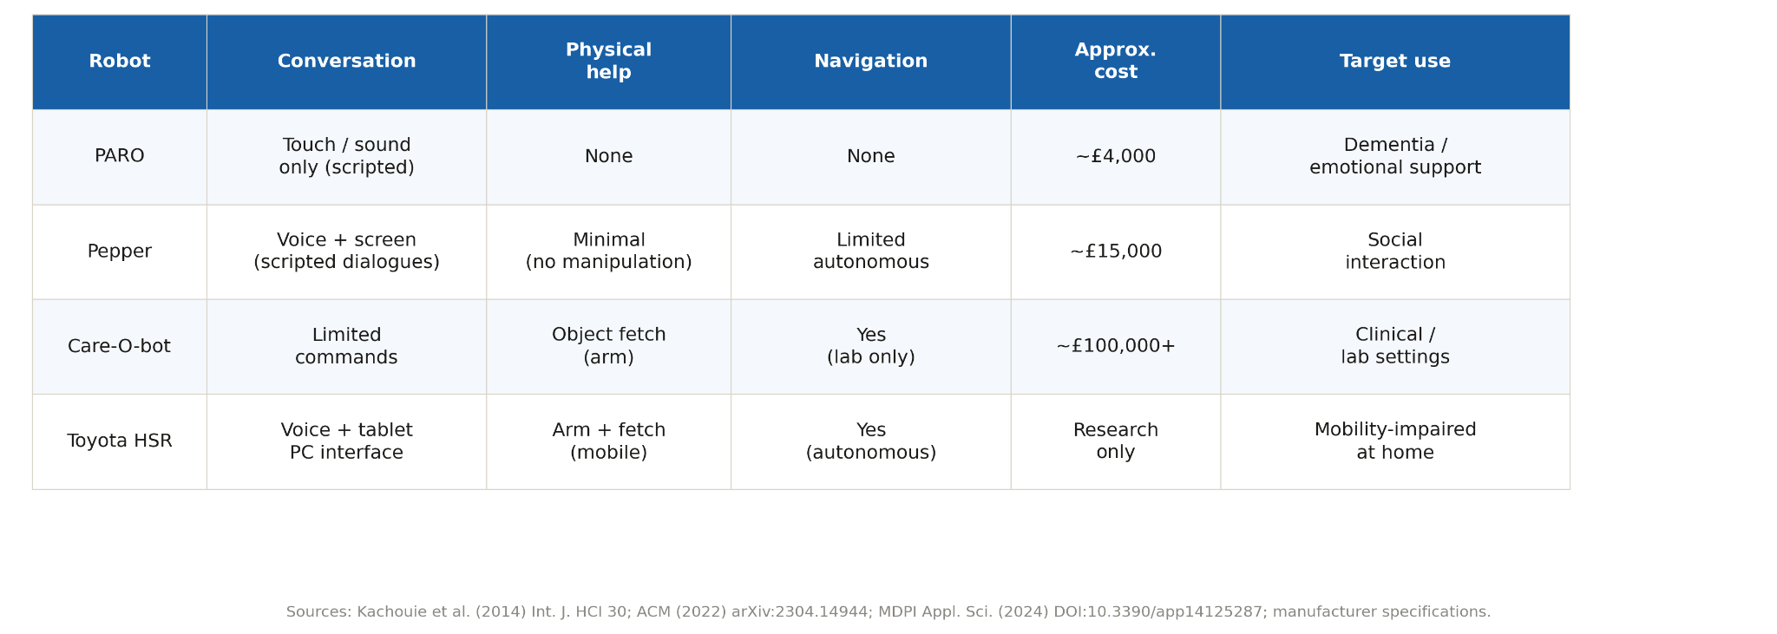

Table 2.1 PARO/Pepper/Care-O-bot/HSR comparison

2.8 Research Gap and Motivation for This Project
Both technologies have their own distinct advantages but their capabilities are not blended into one single all-encompassing system. Robots are either used as navigation aids or companions; so as such, robots serve as guide robots or conversational robots; however, the double-use nature is extremely rare. An AI capable robotic companion, that can comfortably interact, complete domestic tasks, and autonomously navigate homes needs to be developed. It is important to combine two radically different types of technologies into a cohesive system; on the one hand there is probabilistically driven AI, such as language generators that allow robots to carry on coherent conversations, but are highly unpredictable; on the other hand there are path planning and task routines, that provide reliable and accurate control over critical actions, but lack the adaptability provided by AI. Both sides have an advantage in areas where the other does not excel. Combining these two, while maintaining the adaptability from the AI with the safety that traditional control mechanisms offer, is the key goal. Thus far, no such system exists, and this is precisely the gap which the project endeavors to fill. Keeping in mind the demand for such robots, as well as current technological trends, the section that follows will outline how the system will be created.

Chapter 3 — Project Vision and Planning
We envision the development of an AI robot which will not only provide conversational engagement with elderly people, but will assist them in their daily activities as well while maintaining the highest standards of security for the user. This robot should be mobile within an apartment environment, perform companion duties, as well as housework. The difficulty here is balancing the probabilities involved in the AI and the concrete control of actions. We will have to make sure that our system will be neither too lax to be relied upon, or too rigid to work. Although the robot has not yet been constructed, the task can be considered feasible.
In the first stage we determine what is required to build our project; We will determine the user requirements, the state of current science and the organizational requirements and then formulate a project which is based upon these requirements.

3.1 Vision of the Project
A part of artificial intelligence is the usage of natural language for machines. This allows the machines to complete tasks that are helpful such as the need for a robot butler for the elderly that will take care of them. The machines previously cannot assist in any great capacity but can now offer a huge helping hand. The most advanced of these bots are able to communicate through the use of speech, they can even listen to elderly people if they have something to say and have even become intelligent enough for the people to be in control of the conversation. This offers a two-fold effect, task fulfillment and entertainment for a lonely elderly person.
The tests carried out at present are not to verify any theories or mathematical constructs. They are only aimed at demonstrating the operation of the technology and as such is an example of the second stage of the framework, where conversation should logically build upon that of others, in a productive manner.

3.2 An AI-Centred Design Philosophy
It must not be seen solely as a navigator and chatterbox but as an autonomous companion robot. As a companion, the robot has to provide physical assistance, conversational support, retain memory for later interaction and carry out routine checks.
To implement this kind of flexibility, we are analyzing the natural language interaction of old people with computer systems. It is found that even if it is easy to constrain speech commands to a certain set of words, it's rather hard for the old people. They are able to use natural language commands like "Take me to the kitchen." and "I have to go to the kitchen.".
In this project, our objective is to integrate these two concepts: one is the natural human-machine conversation and the other is independent domestic navigation, which eventually makes an intelligent companion.

3.3 The Choice of NAO and Webots
This research used the NAO humanoid robot and the Webots simulator environment. Webots is well known in academic circles, as well as in industry as a highly effective robot simulator for design and testing robotic systems and sensors in a highly realistic three-dimensional environment. The simulator includes a physics engine which offers a higher degree of accuracy regarding the real world behavior of robots and their movements (i.e., collisions and gravity). A broad spectrum of programming languages are supported and the program includes various models for already existent real world robots, which can significantly speed up development [44]. The reason for choosing Webots is mostly practical considerations for the experiments with elderly persons. Situations, such as navigation and falling failures of elderly people, cannot be safe or financially viable in the real world, and these scenarios may be identified and fixed in early stages through simulation [41]–[43]. Also, the Webots Supervisor tool allows experimenters full control of the experiment: they may alter values for each variable present in the simulator and influence the robot behavior by changing certain parameters, allowing the behavior of the robot to adapt to various conditions of the environment. Because experiments always begin at the same time, greater confidence can be placed in the resulting data since the effects of even minor variations in the test set up can be eliminated [44].
The NAO humanoid robot is a robotic, created by Aldebaran Robotics (who are now part of SoftBank Robotics), designed to assist humans in social contexts (see Figure 3.1). That is why a humanoid robot like this was selected. This is a humanoid robot that can communicate through speech and gestures and has a morphology that creates a human-like interaction, promoting the perception of a companion rather than of an object.
Both NAO and Webots allowed us to work around the door movement issue that occurred from the simulation reset, and it appears that the initial conditions, however small, are extremely important for the tests that are carried out, therefore, having a mechanism that allowed us to reset the simulation was crucial.
It is clear that NAO has several strong points and weaknesses: The sensors on the robot seem to operate much better during simulations on Webots, due to the fact there is not any real-life noise interfering with sensors [45]–[47]. Also, it was much simpler to control the NAO robots on the Webots environment due to the lack of mechanical problems that arise, and the navigation difficulties described previously



Figure 3.1 NAO Robot
The small site of the NAO robot allows for an easy implementation in human homes or workplaces. Consequently the laboratory tests take place in a miniature version of a house with the appropriate sizes miniaturized.

3.4 The Real Software Architecture
In order to avoid the issues discussed in the previous sections, the software architecture must be split up into well defined and linked modules. A robot assistant, within the home, needs to be able to, listen to commands from the user, interpret user command intent, decide upon actions to perform, navigate itself, supervise its task and have a minimal social interaction capability. These needs reflect the overall requirements expected from home robots, stated in [74] and [75] (i.e. Safety, interaction, adaptability and usability). These functionalities, being quite varied, can only logically be grouped into separate software components. Compiling all of them into one will prove to be a "unmanageable mess" thus mandating the use of modularity.
The software architecture proposed here is composed of 5 distinct modules; Communication module, Decision-making module, Navigation module, Perception and monitoring module and User-assistance module.
The Communication module is responsible of the basic interaction with the user, taking commands via natural language or by text. As this is an assistant robot, if the user cannot interact with the system simply, due to e.g. Their immobility or lack of knowledge, the robot is less effective. Natural interaction is thus key and can be attained through speech recognition and conversation support [57].
The Decision-making module interprets the user command, and initiates the response. Therefore the system will need to answer a simple question, have a conversation, go somewhere, assist the user or simply refuse to take an executable command or provide an invalid input. The Decision-making module connects the user intent to the system behavior. In a structured manner the system needs to recognize the task, plan the execution, perform it, and supervise and replan if necessary [60].
The Navigation module controls robot movements within the home. It is necessary for ensuring the robot safely and efficiently moves from A to B whilst using learned pathways and operating household appliances, such as doors. Due to restricted or obstacle-filled environments within homes, navigation is a vital, not an insignificant, component. It necessitates the use of approaches such as behavior control and path planning [59], [77].
The Perception and monitoring module, ensures the robot is aware of its environment, its current surroundings, and the progress of a task. It will recognize when something changes and if a task is deviating from the expected; preventing unnecessary errors and hazardous behavior. It is important that the system is aware of these factors to enable efficient execution of tasks, particularly with moving human inhabitants changing the room structure [74], [75].
Finally the User-assistance module will enable all robot-human tasks other than basic locomotion and command interpretation to be achieved, including; casual conversation, task reminders, inquiries about well being, etc. Allowing the robot to act as a true domestic companion.

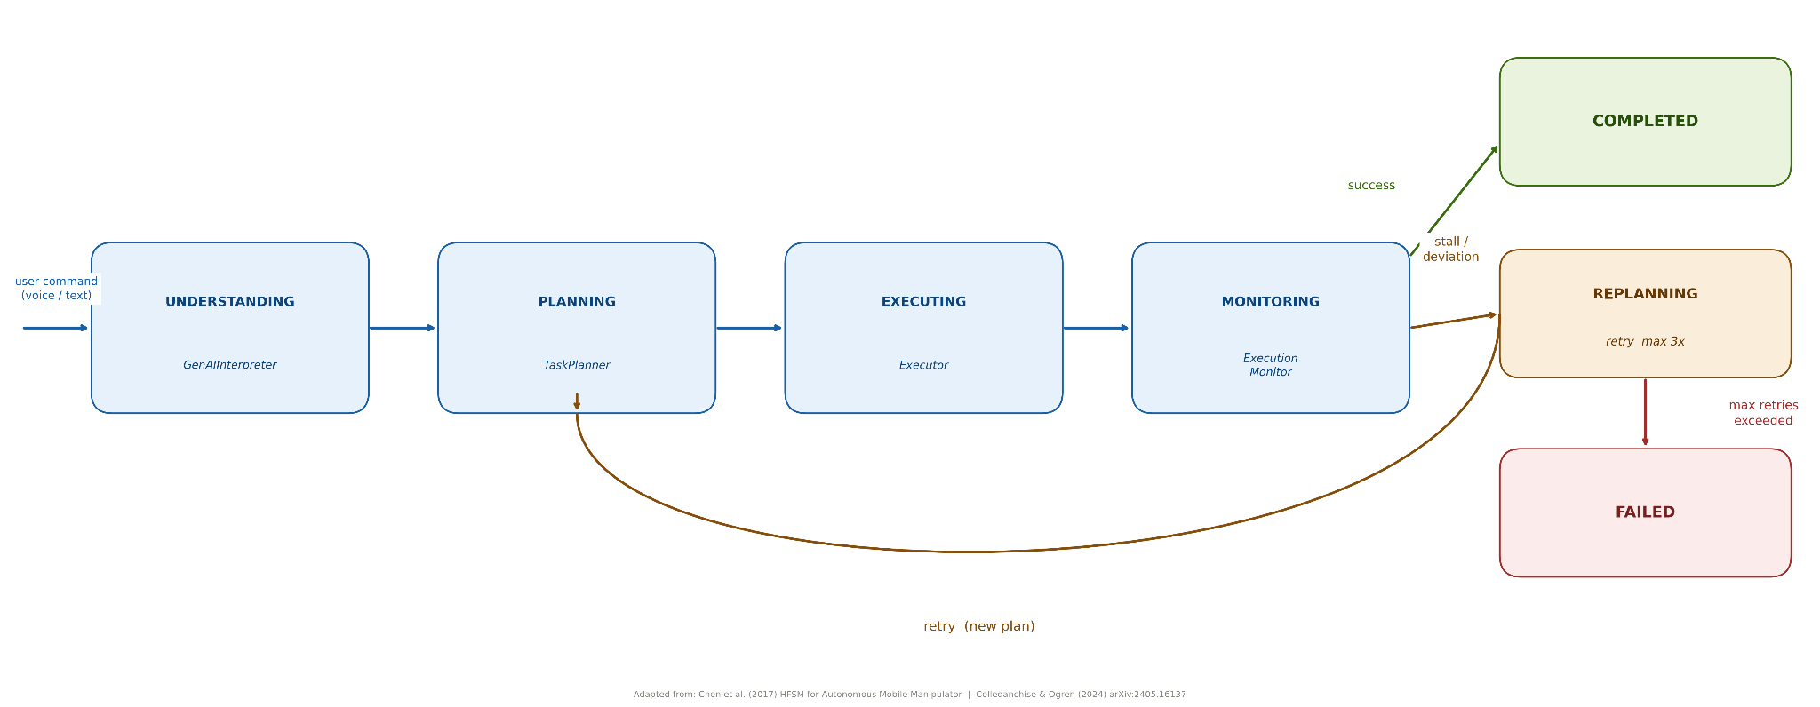

Figure 3.2 RobotBrain

3.5 The AI Integration Strategy
The goal of this project is to develop a stand-alone robot, which could function using generative AI and the necessary methods to implement it, while remaining extremely safe. While these AI models are great to carry out humanlike conversations, they can also give varying responses, even given the exact same input. With conversation, incorrect answers are no longer an issue, yet these are the responses which could end up being given in physical tasks. Therefore, there needs to be a method for allowing these models to work without putting the user or the robot at risk of anything that could potentially occur due to the model working inconsistently.
This combination of AI and deterministic robots lays out specific roles for both AI models and robotic controls. Firstly, the AI needs to be trained to recognize user commands both spoken and written. Unlike this application however, robots themselves will not respond to the commands and will simply obey certain robotic protocols and safety features in order to complete their jobs reliably and safely.
A smart idea which can be used is to utilize multiple smaller, targeted AI models rather than a large general-purpose AI. One module can interpret what the user wishes for the robot to carry out, which is the AI's function. The other module can continue with the chat-based interaction and the storing of individual preferences, family names, routines and any required help, which removes it from interfering with any of the robot's basic needs.
To assure the safe operation of any AI generated commands, all proposed actions will be verified to be deterministic before being implemented into robot actions, therefore, a robot will always be able to know what actions are required from it before taking them, although it will know the possibilities based on the conversations it has, it can rely on verified means of actions. It's aim is to blend AI's verbal and interactive capabilities with reliable robotic performance.
In order for the system to function completely independently without relying on cloud access, the stand-alone robot must have a system which will allow it to perform key functions using its preset instructions and scripts. This is how the stand-alone system would still operate in case of no access to the external AI or due to interference.

3.6 Navigation and Assistive Planning Philosophy
This proposed navigation method has been designed for the assistive robotic system to navigate a human environment, instead of an autonomous exploration. Different to the other method, this method is purely follower to the human. Only when the user asks for it or it has indicated need for assistance it will move, thus the system always react based on the situation.
This approach to environment representation is high level. Instead of considering the environment as the typical occupancy-grid, here the environment is considered as a graph where the nodes represent landmarks or regions, while the edges represent the ability to move between them. This shifts the planning focus from solving small local steps along the route to planning from large picture level of problem -solving problem solving. Navigation becomes then a "goal reaching “ task within the big picture.
Here, assisted navigation has been framed as a goal-oriented process which attempts to determine if a desired location is reachable or not. Navigation task does not require complete autonomy but rather act as a guided service. System intervenes with navigation or escorts whenever an assistance is needed and then returns to idle status after the tasks is completed. Hence navigation path selection aims at the optimized navigation path within environment and safe boundary constraints.
This leads to the easily predictable and controllable behavior of the robot in assistive robot application domains like elderly care, and other similar assistance oriented systems. It is achieved by reducing the navigation to goals and task oriented processes, eliminating the undesired random behavior and performing intervention tasks to deliver required assistance.

3.7 Development Methodology and Iterative Planning
They made use of both simulations and experiments. By observing how the robot behaves during each of these activities, the design decisions were made and it was refined as required. Instead of a defined design process, they looped around changing, simulating, error analysis and modification until the robot's performance gradually improved.
The robot design process was more iterative than that of V-model. Because initial assumptions on how interaction problems were to be encountered were not fully defined, several surprises arose when performing tests. These discoveries led to design changes due to the analysis performed by the simulation. The design was thus modified instead of proceeding with the initial design plan based on what was found through testing.
A few notable problems arose while testing. Stability was an issue, as was dealing with a new environment. It was found that the robot would frequently fall over on initial tests, and encountered difficulty when approaching doors. This revealed that some initial assumptions about sensor and motor operation were flawed, hence changes to rules and refining the navigation was carried out to improve the system performance.
These were solved through plenty of trial and error, very similar to the Software Engineering Process Spiral model where each spiral iteration is mainly for evaluating the risk and then building and testing the prototype of what will be built in the following spiral. They overcame the bug errors by trial and error and the navigation issues were resolved. Empirical test results of actual robotic behavior proved to be a much better indicator of adjustments needed over purely theoretical reasoning. These adjustments via simulations proved to be realistic.

3.8 Project Planning and Implementation Stages
The system was developed in stages. It was first setup with its required components including the Webots simulation and the NAO robot. A controller and a Supervisor were then added, this was designed to be aware of the door state. This was followed by speech recognition, converting the spoken word to text. Finally to enhance the AI's communication abilities a command parser and an auto assistant were developed in order to allow more fluid dialogue between user and system. Once the whole process was complete the logical and motor systems matured to work as two separate state machines acting together in a hierarchical planner-like architecture rather than a rigid grid. During the interaction the state machine representing the assistant had consistent behavior. The four modules of interpretation, planning, execution, and monitoring could finally be bound together in a single system. The tests at the end showed one main thing that AI integration increases performance considerably.

3.9 Critical Analysis of the Architectural Decisions
The advantage of the discussed architecture is modularity. Having each component independently testable should lead to ease of maintenance and debugging (critical in robotics) of individual system components as failure typically happens on just one component. The issue of the system exploiting ambiguity within commands and sending out faulty signals is circumvented through the system's architecture separating the natural language parsing from the robot command execution. The system offers generality of application for different conditions in various room arrangements. A weakness with this system is that it has the tendency to do poorly when the natural language does not follow typical grammar and conventions. The system also relies on an external cloud-based service which introduces concerns about the service being down or increased latency as there is no local processing. The issue of an unnoticed system failure, hence no basis for parameter independent testing, is still present. While the Webots simulation provides for fairly complete simulation some real-world conditions can not be simulated and this leads to a diminished performance in some lab/field conditions compared to that in simulation.
Overall, the system presents a good compromise of safety, usability and modularity while allowing for future, critical, decisions to be made regarding this bigger issue. The following section describes the execution and modification that takes place within the robot's actions.

Chapter 4 — Project Implementation

4.1 Introduction to the Implementation
We have covered the conceptual ideas of the last chapter, and now turn to discussing how they operate in a working system. In order to interface the system into the live simulator, connect it to the real-language models, and ensure it functions considering robot's physical constraints, we have to well combine layers, artificial intelligence technique and the major objective of system. That had been achieved through a large number of experiment. Our significant problem was not how to find out new things, but how to make these new things go along well with already existing things, such as speech recognition and path planning. This work has an impact on the way how we link those things together to provide smart interaction, which brings about concrete outputs and less risk-prone errors for robot motion.

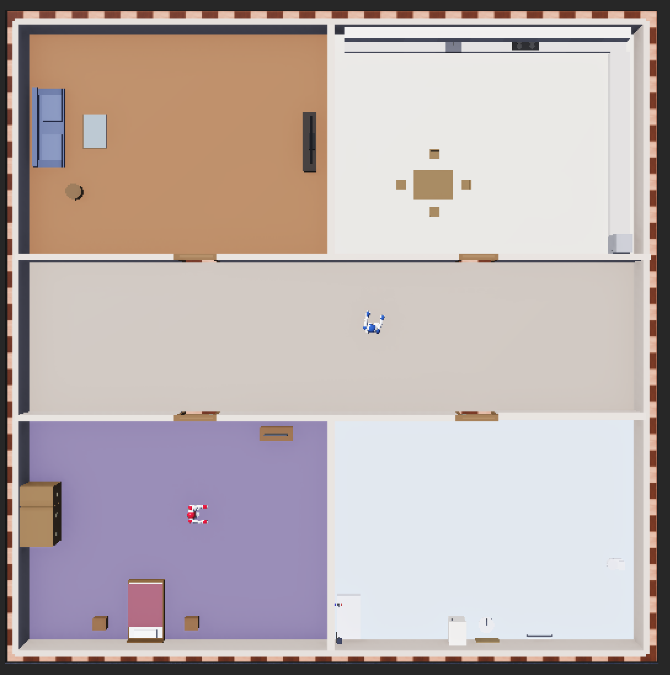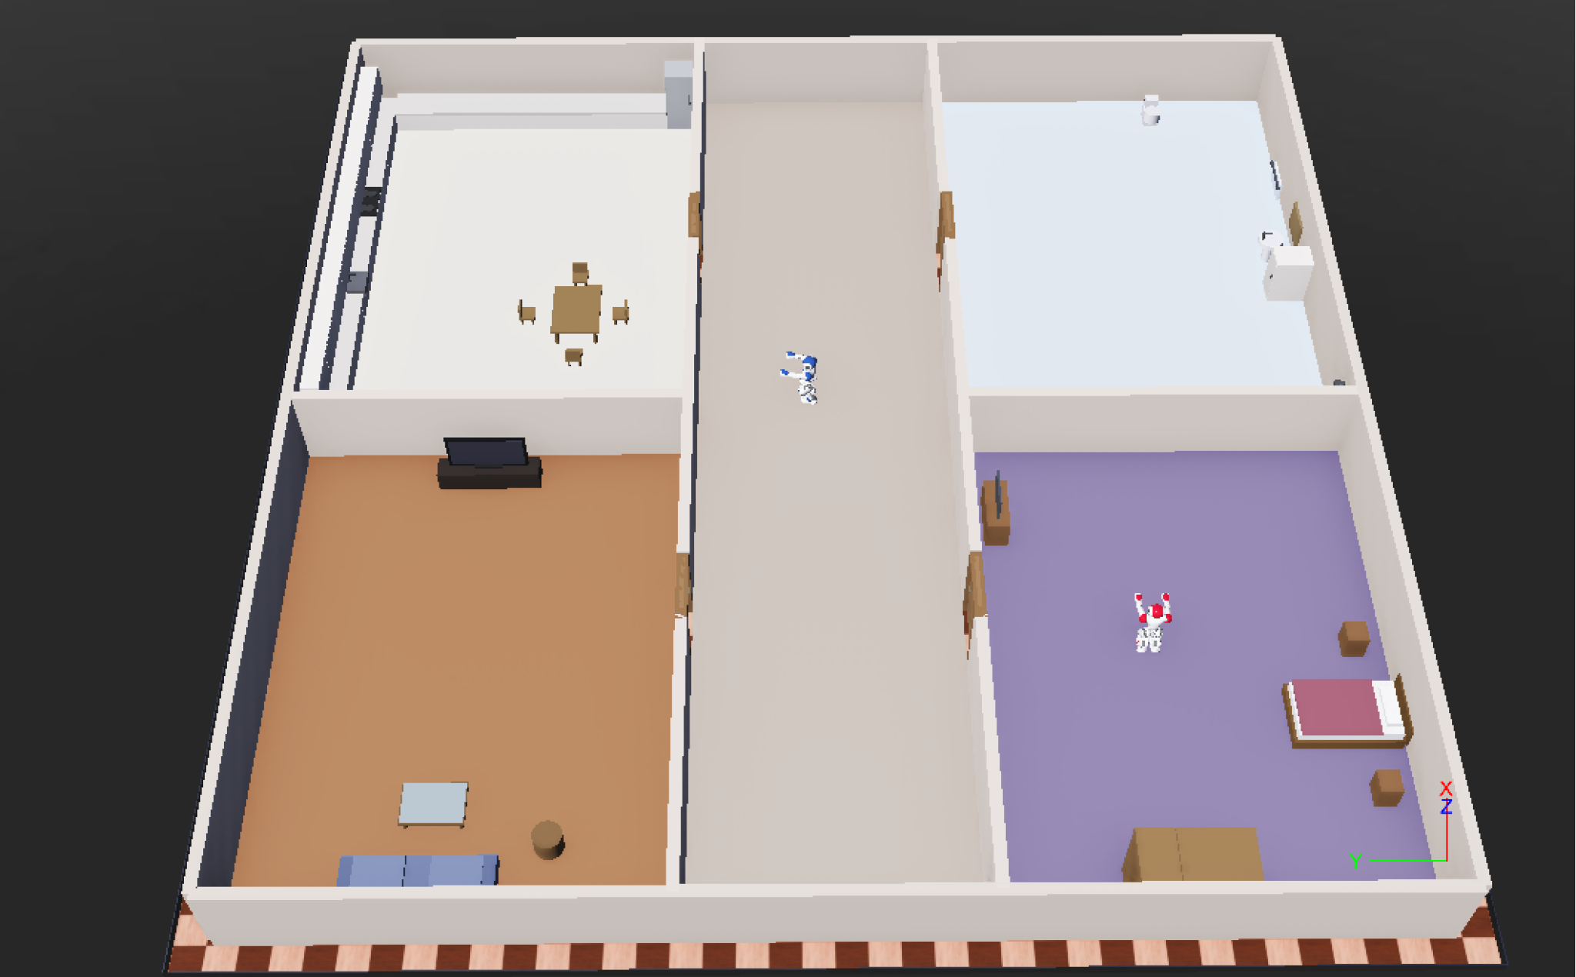

Figure 4.1 Upper view layout house Figure 4.2 Side view layout house

4.2 Overall System Implementation
The robot system consists of several processes working together: we don't just have one app. The simulated home layout is shown in Figures 4.1 and 4.2, and the overall software architecture in Figure 4.3. In the Webots simulation two controllers run simultaneously: the naoassistcontroller.py for the service robot and the door_manager.py for the doors. We have an external process working outside the simulation to record and process voice input. This isolates the voice recognition from the service robot's functionality and prevents the primary operations of the robot to be interfered with if the speech recognizer crashes.
We have two channels for the robot's communication: The robot receives spoken requests from the outside world in text form via a TCP socket on port 5005 and then, uses a radio emitter-receiver thing within Webots on radio channel one to communicate with the door controller for door management, [52], [53].
The controller's main loop: To have a robust execution each time step is performing two key operations: first update the assistive state machine and permit the helper sub-system to run when there is no task active, and second check for commands entering the controller via TCP socket or a dev command file. Orders are executed in the following priority: system reset, control of the assistive state machine, interpretation of general commands. This ensures the assistive tasks are always considered before normal conversations.
Listing 4.1 Is the simplified structure of the main loop of the controller. The loop prioritizes the assist FSM over normal conversation commands to avoid having support tasks interrupted by general conversation.

while self.robot.step(self.timestep) != -1:
self._refresh_grandpa_position()

if self._assistive_state_machine:
self._assistive_state_machine.tick(self.robot.getTime())

if self._companion:
assistive_busy = (
self._assistive_state_machine is not None and
self._assistive_state_machine.state != AssistiveState.IDLE
)
for msg in self._companion.tick(time.time(), assistive_busy):
self.say(msg)

for msg in self._read_tcp_messages() + self._read_typed_commands():
if is_reset_command(msg):
self._perform_reset()

Listing 4.1 Controller main loop priority structure
In this listing it should also be noted that the state machine has priority over tasks. The assistance state machine should be active when the conversation state machine is disabled and thus active support behavior should be preferred over casual communication with the companion. The companion system will be enabled to speak only if no assistance task is being executed, and the system reset commands should remain active as a safety measure. Additionally, this structure promotes modular implementation, as all actions (navigation, assistance, conversation, emergencies) are executed in one loop.

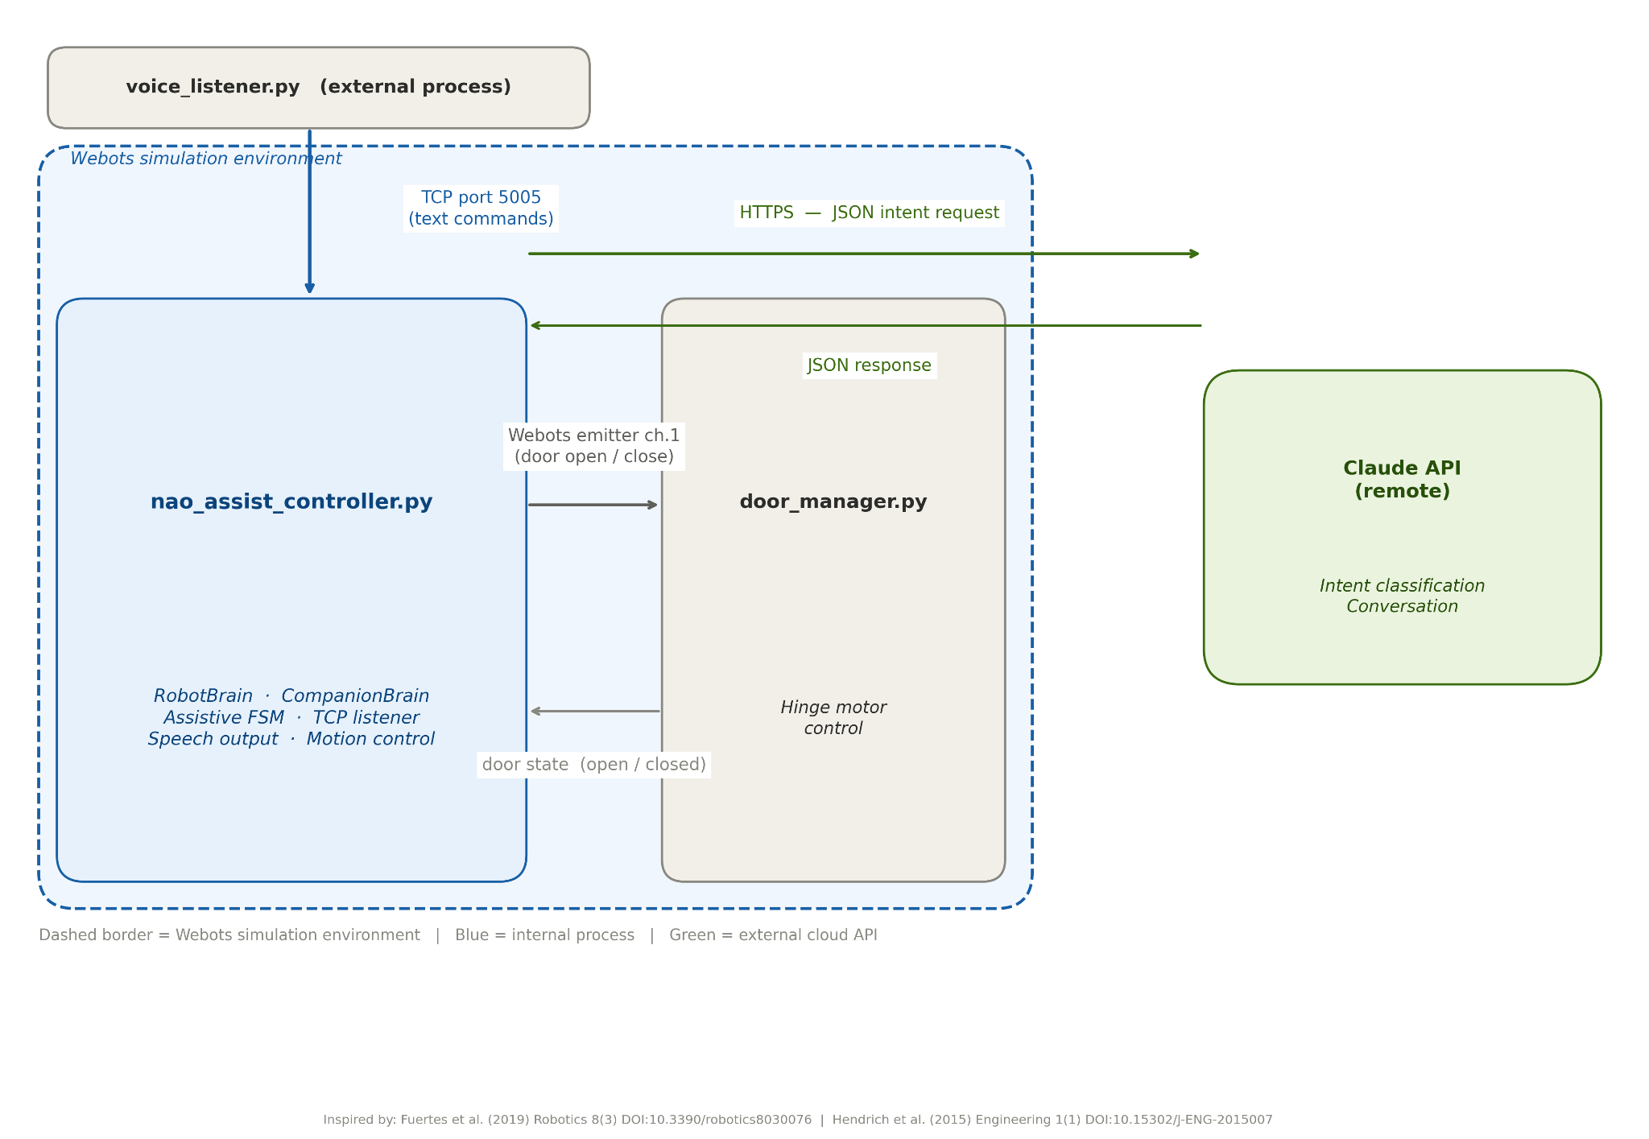

Figure 4.3 System Architecture

4.3 Conversational AI Implementation
The two components of the conversational subsystem must work together, although the other is separate. Both are linked via the same language model, one as an interface between the system and command parser, the other as the conversational system. Both require their own instances of Claude Haiku so the system will still function if the language model is offline.
In the same vein, there is a two layer approach of the command interpretation subsystem. The two layers are the deterministic parser, and the GenAIInterpreter. The deterministic parser should handle all straightforward commands, remove politeness, break down command into categories of navigation, escort, door operation, and room-list queries [54]. These commands can be directly satisfied and don't even require any network interaction.
All other non straightforward commands go to the GenAIInterpreter, this module is designed to call the language model and format the intentions of navigation, task execution, and door operation into a structured JSON response. At this level the language model should be able to respond to conversational, and indirect commands without the actual command of the system being interpreted.
Listing 4.2 Demonstrates the model-first design utilized within the command interpreter. The language model is first consulted when available, while keyword-based interpretation is invoked when the model is inaccessible. This ensures that the robot remains operational when the remote AI service fails.

def interpret(self, user_input):
# Language model first; rule-based fallback if it is offline
if self._client is not None:
result = self._call_api(user_input)
if result is not None:
return result
return self._keyword_fallback(user_input)

def _call_api(self, user_input):
response = self._client.messages.create(
model="claude-haiku-4-5-20251001", max_tokens=256,
system=self._system_prompt,
messages=[{"role": "user", "content": user_input}],
)
return json.loads(response.content[0].text.strip())

Listing 4.2: model-first interpreter on conversational AI component with fallback
This listing shows how the conversational AI part can be integrated into the system without relying entirely upon it. The interpreter first uses the language model to process and understand the input more flexibly, however if the language model is unavailable or unable to provide a response that the program can interpret, the same function returns the basic intent generated by the keywords search. This is good in case of reliability since the robot would still understand basic commands without the generative AI part.
The conversational subsystem is responsible for the social and emotional responses of the system. Every command is evaluated by certain filters before being passed on to the system's response, filtering out things such as commands requiring personal memories, family matters, medical advice, user feelings of depression or illness, and simple commands such as current time and the weather. If the parameters match, a canned response is provided and logged into the user's profile instead of their conversation history.
After the parameters have been checked and the appropriate canned response has been sent, the command is sent on to the language model. The response should be supportive, warm, unintelligent as far as artificial intelligence goes and cannot provide medical advice. To ensure that the user doesn't have to stare blankly if the language model doesn't parse the command correctly, a ticker should be programmed to continuously query the language model when there are no other tasks in the system. Due to the constant querying, a companion can say "Welcome back" and suggest a recreational activity, "Make sure you are hydrating," or inquire about health information based on user data [55].
Overall, there are three levels within the system; the deterministic handlers, generative responses and scripted fallbacks (see Figure 4.4). This allows a smooth interaction for simple tasks to complex linguistic interpretation and provides guaranteed responses if the language model fails. There are though still subtleties that differentiate deterministic and generative responses.
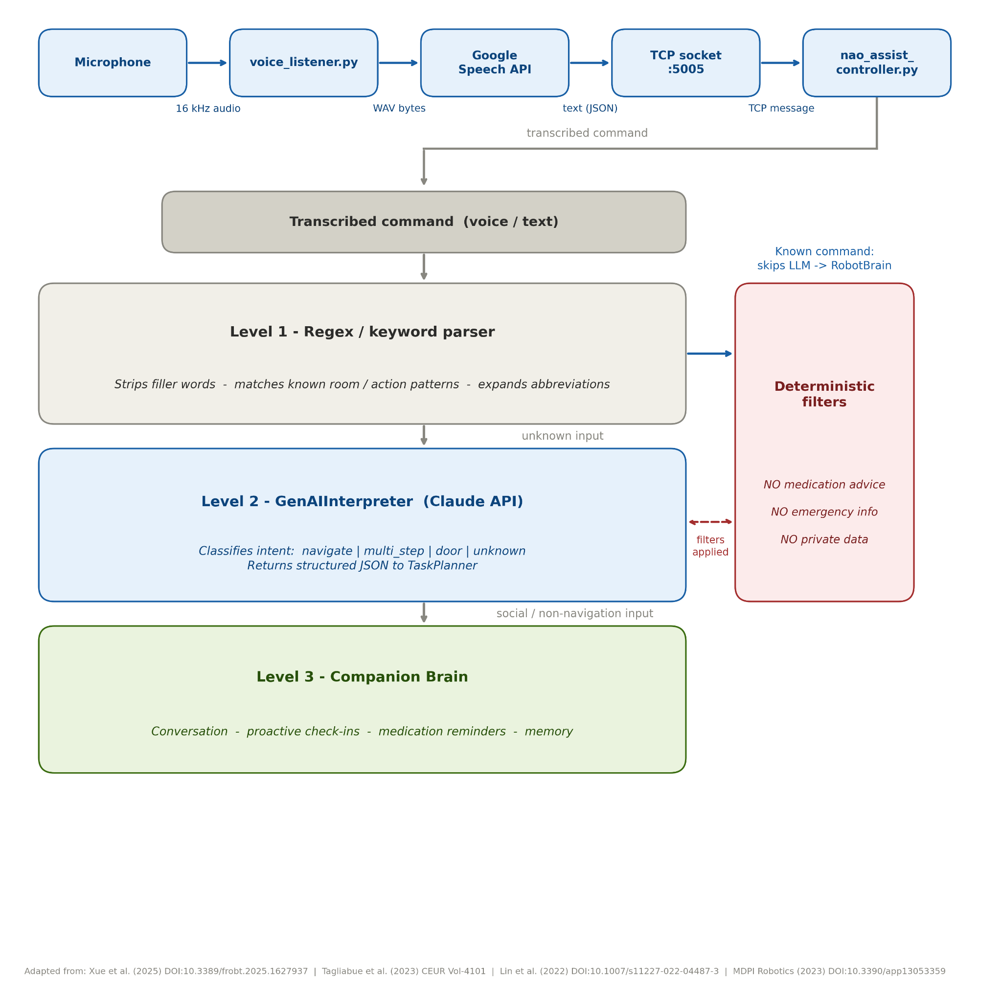

Figure 4.4 Conversational Pipeline

4.4 Voice Interaction and Communication Systems
The voice_listener.py is stand alone from the Webots simulation. The module capture the speech input of the short audio, take samples at 16KHz, convert the samples to an in memory WAV stream file and stream it to Google Speech Recognition API to generate speech into text [58]. The text is filtered out from politeness terms (please and thank you) and room names or abbreviations are mapped to words, which then mapped to commands. The commands that stops the programs and locations that can be selected are identified and filtered out.
The Authors have made the speech recognition to be stand alone as not to make the main loop of Webots stuck. Performing audio capture and speech recognition on the cloud via the controller may make the robot pause in a duration that cause problems in robots' smooth movements. The authors has also make the speech recognition as stand alone as this process can ease debugging, maintenance and helps to rectify errors if the Internet connection is down. It also sends the recognized command together with the id of the person giving command back to the controller.
Though, this method is good to use, there are some shortcomings in this method. Internet connection as well as a third-party provider has to be stable to get the accurate speech recognition results, mistakes by third-party may results in wrong command being selected. There is some constraint placed on conversations as a fixed amount of time was dedicated for recording audio, participants were required to speak short, discrete bits of conversation within specific time limits; this does not resemble natural conversations completely.

4.5 Navigation System Implementation
Navigation is what was most difficult to implement. This stems from doing sophisticated mathematics for relatively trivial everyday things such as entering a room for people who have balance problems, and is even more of an issue for robots with similar issues. Path planning is relatively easier by comparison. Robots can not travel in straight lines from A to B and instead have to seek the best path.
We represent the world as a weighted graph where rooms are nodes and hallways/corridors are edges [79]. To search for the path, we use Dijkstra's algorithm instead of approximations from A* algorithm for simplicity (see C). Most importantly, when creating a navigation plan, the TaskPlanner takes into account of actual door locations, and sidesteps from the prior problem with walls. Doors and entrances are included on the fly as the plan is performed, and assist in the passage of some locations, and help the robot to navigate around other issues.
During system initialization, it detects problems such as errors in map information which could interfere with system operation. After the graph has been constructed, the actions taken are: travel to door, move beyond door, travel through door, travel to target location [76] (see Figure 4.5). The problem of navigation rests solely on room connectivity and the robot will not travel from an arbitrary room without there being a passage out of that room (door exit locations, see diagram):
Listing 4.3, the planner transforms the target room into a list of door actions. The system can't navigate the robot from one room to another one, it extracts the door-list necessary for the pathway and then each door is expressed in a fixed sequence of navigation action.

route_doors = self._house.get_route_doors_for_target(target_id)

for door_id in route_doors:
actions.append(("navigate_door_approach", door_id))
actions.append(("verify_safe_approach", door_id, ...))
actions.append(("open_door",door_id))
actions.append(("cross_doorway", door_id, target_id))
actions.append(("navigate", target_id))
Listing 4.3 Door-based route expansion in the task planner
This listing explains that it is not just a case of driving directly forward to a specified room. The approach is instead modelled as an iteration based on doors to be traversed to reach the destination room, each door being traversed in a loop: move forward, orientate correctly, open the door, go through door. This seems a far more realistic navigation paradigm in a home setting where rooms are not just an open space, but connected through doors.
The system is executed, the difficult aspect of which is described above as most tasks are directly concerned with the passage through a specified set of rooms. This task takes an action, which is executed to a function, producing some information about either the function return value, completion state, and/or the reason why the action failed. As for movement between rooms the robot needs to take control in order to remain balanced while moving between target locations, when a robot is sent to travel through a door, the robot will get clearance from the door module, which permits movement across the opened door, into a new area, and onto a new planned route once the door is opened. Precise positioning is not necessarily required in order to pass through the door; the passage of the robot may suffice as enough to allow coarse alignment. The algorithm can deal with both center location, and orientation of the door with hinge position. Config files may adapt this system to other home layouts without requiring changes to the software; they specify locations of rooms, entrance/exit points to rooms and hallways, etc and so allow for any of the goals to be met (see B). The major current limitation on generalizing across different home configurations is the transitions in and out of doors due to geometric limitations. The execution phase entering/exiting a room is not limited in the same way.
Listing 4.4 displays modification to the doorway crossing point when the door is open. The crossing point of the doorway no longer automatically pass through the geometric center of the doorway. In this situation the algorithm translates the crossing point of the doorway away from the door leaf by examining the position of the hinge.

def _free_opening_center_x(self, door_id, cx, cy):
posts = nav._doorway_detector.door_posts(door_id)
if posts is None or not det.is_door_open(door_id):
return cx
hinge = self._hinge_pos_2d(door_id)
hinge_on_west = abs(hinge[0]-west_x) <= abs(hinge[0]-east_x)
bias = min(self.DOOR_LEAF_BIAS_M, max_bias)
return (cx + bias) if hinge_on_west else (cx - bias)

Listing 4.4 Door opening centre adjustment using hinge position
This listing shows the navigation algorithm's awareness of the doorway's physical status. With the door closed, it may attempt to find the normal centre of the doorway. When the door is open, the crossing point is offset from the door leaf. The possibility of the robot running into the open door or the frame are lessened, and provides some insight to how the robot overcomes the problem of doorway passage more securely.

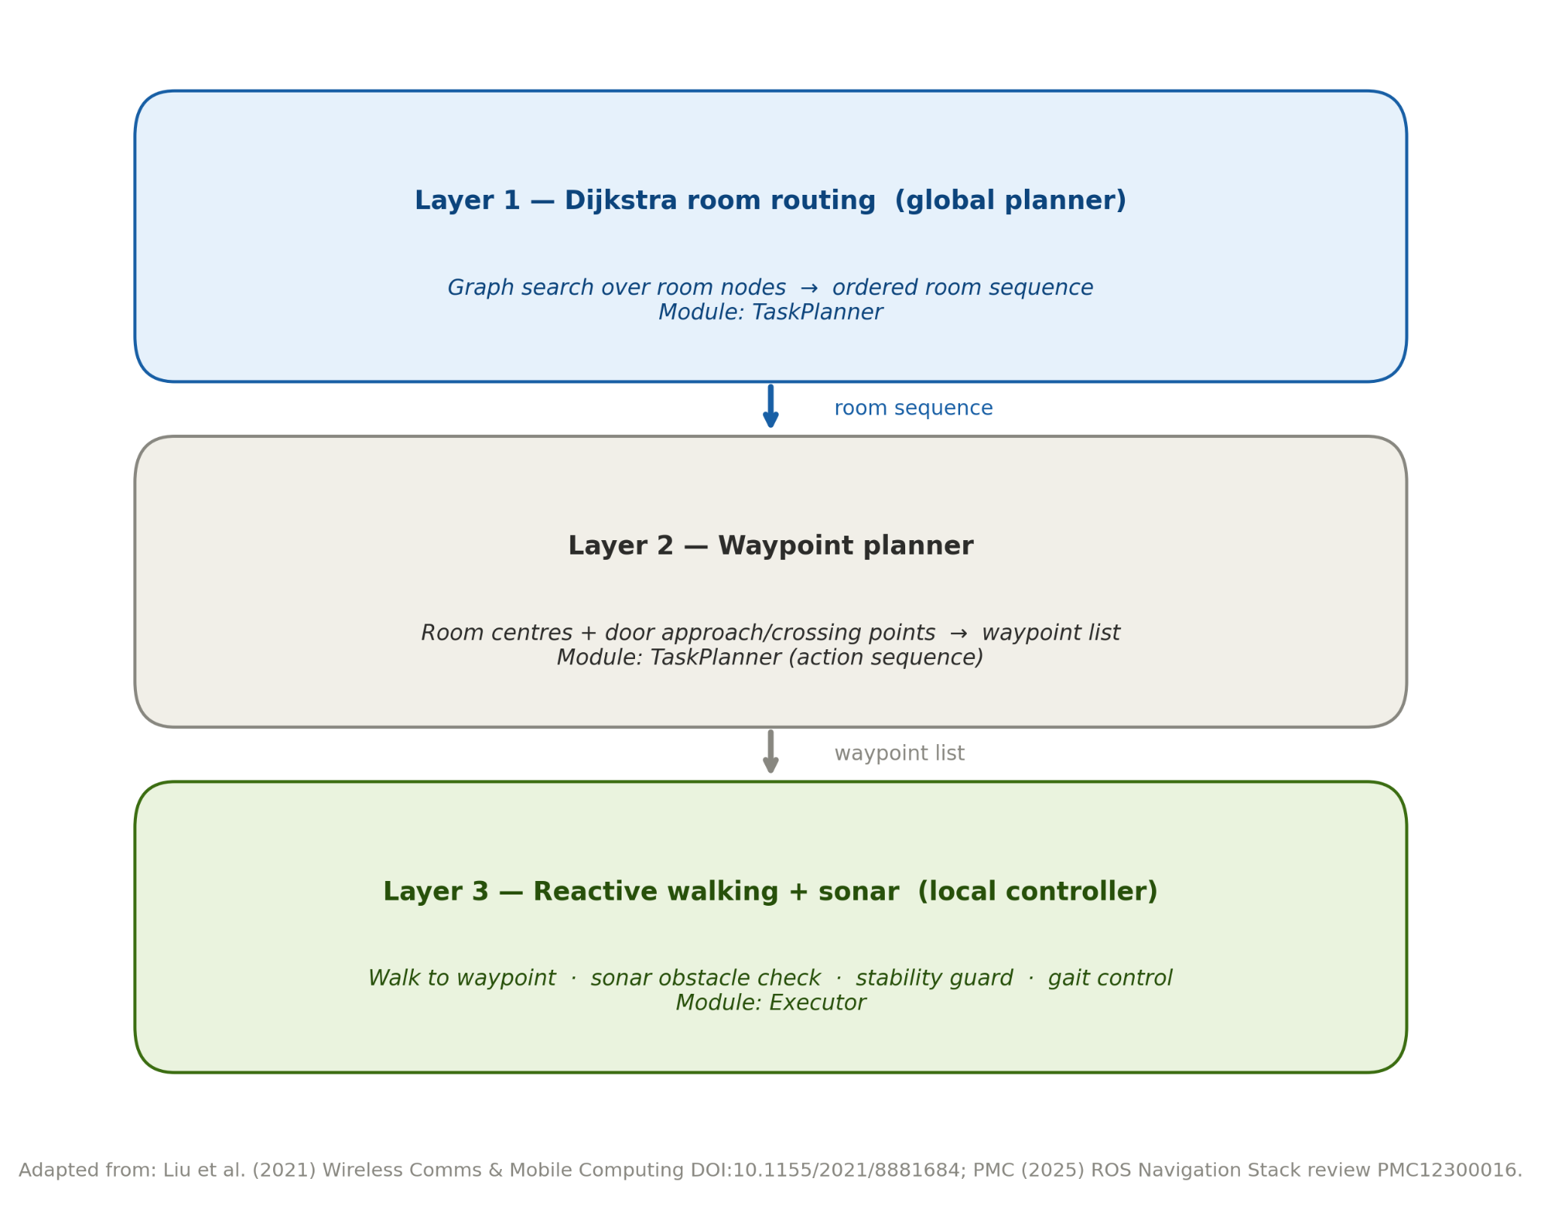
Figure 4.5 Navigation Layers Diagram

4.6 Assistive Task Implementation
The robot assistance is controlled using a self contained finite-state machine which works like and unlike a navigation system. Initially no assistance is active.
When the human asks for robotic assistance for navigation towards a particular location the robot will wait in its current position until an exact location is calculated for the human who has asked for help. If an exact room specification is calculated, the program state goes from the idle state, to the wait for location state and if room information is unavailable the state remain unchanged and no task is performed.
A robot stationary for approx 30 secs after repeated tries, is rebooted, which can then return to its position and provide motivational messages. [61]
Schedules of giving medicine must remain the same and might even need to be re-configured frequently by the user in order that the rules of running the system will not differ significantly and likewise robot need to be configured for picking objects and transferring them from one place to another as it is need to perform this task continuously. [56]

4.7 Environment Interaction
The opening of the door is an automatic sequence when it detects open [key] or close [key] signals on channel one (see Figure 4.6), and starts to move the motors to open it. The robot will step up to order the other systems to work for the task. Due to multiple communication channel system used for this task by home automation can open door for test cases because it is required to open door before robot get into the area.
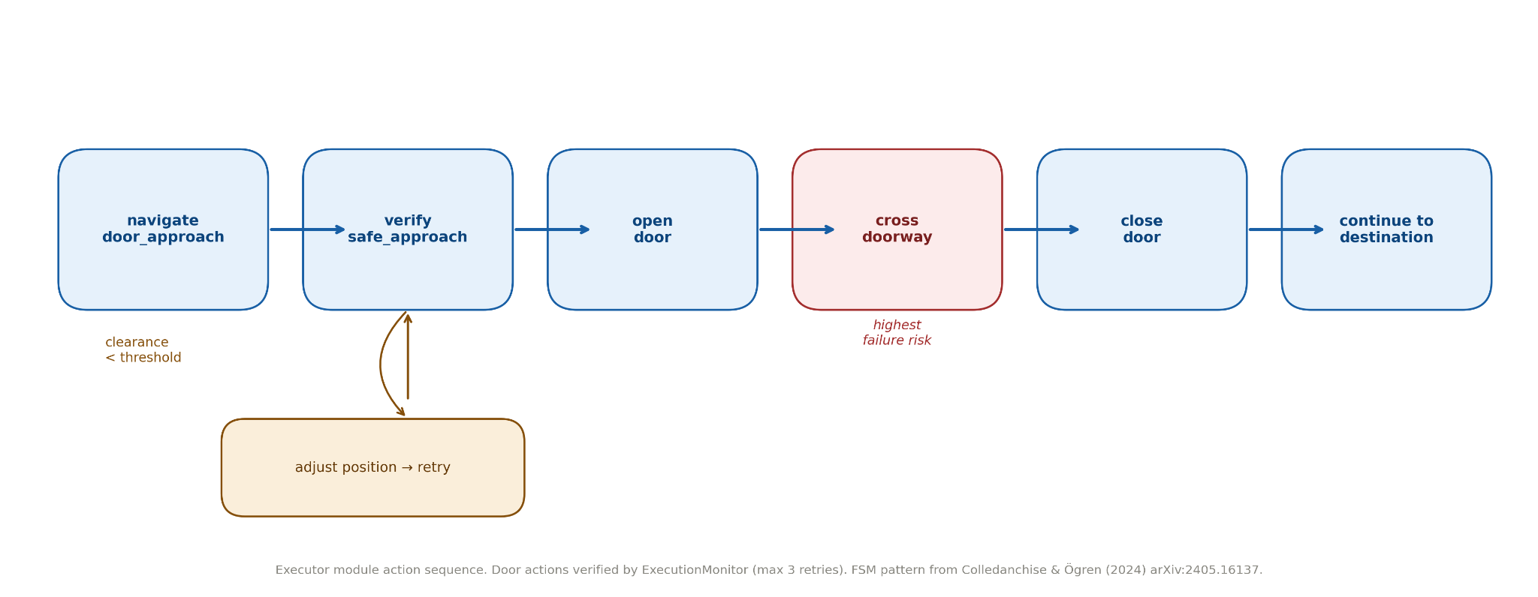

Figure 4.6 Door opening diagram

4.8 Iterative Development Process
The system was built up iteratively and for the most part it was a case of trial and error (not always even from the same plan) [64]. We encountered quite a few bugs which arose from the simulations (Appendix D); for example we had to abandon the grid based navigation system and adopt a room-to-room navigation system, the code for door traversal had to be tested and adjusted many times before it was working reliably.
Door traversal was not simple to implement either. We found that there were many points of failure in test runs, for instance misalignment, orientation tolerance and oscillation while moving through the door. The bugs did not always appear at the same point of translation, indicating the difficulty of translating a plan to the physical system; and fixes often created new issues.
The iterative process demonstrates where the simulation results were really valuable during the design process. The solution that was created was a result of the testing and did not merely follow a single initial plan that was made. It was through this process, and as a result of analyzing failures and subsequently updating the code and design that a much better solution was eventually reached.

4.9 Testing and Debugging
It was all carried out by simulation and by looking at logs generated on a control console recording robot actions. These logs also kept records of the entire navigation, enabling us to map both planned and the predicted path using the Dijkstra algorithm and pin point precisely where the subsystems failed, rather than guess. Many issues we thought were related to programming were actually caused by wrong configuration or incorrect coordinates, for example. The key problems were mainly physical, namely hitting doorframes, and falling over when transferring from one room to another. Also, it failed to transfer between the rooms from time to time and the banging on the doorframe was excessive. It also tended to fail to choose appropriate route between the rooms. In addition, strangely formulated requests by the user jumped over the normal handler and was processed by the language model. Nevertheless the tests identified and fixed many problems relating to door transfer.

4.10 Requirement Analysis and Implementation Evaluation
Almost all objectives are met in the project. The robot is able to find its owner, hold human like conversation, follow simple instructions, move rooms to a door, make a friend, and remind of medicine intake. The robot demonstrates that the concept is feasible and functions for the planned objectives (see Table 6.1).
However, a few objectives are not completely implemented. The two most challenging objectives to fulfill involve finding and traveling through doors and having an object set in fixed positions within each room. Therefore the primary issues are with the monitor program. It is good that it contains a robust stall and detour finding module that can even detect repetitions but the main loop simply repeats commands and therefore uses outdated information causing the simulation runs to stop.

4.11 Critical Technical Analysis
An advantage of this system is the modularity it features. Each component of a speech recognizer, interpreter, planner, actor, monitor, dialog coordinator, door actuator is tested independently by its interface and through its own channels [62]. This allows for easy debugging and changes in an element (such as the speech recognizer) does not break everything else. It is also useful how both probabilistic and deterministic approaches combine; problems within the speech recognizer just create wrong sentences, and not whole system crashes.
The difficulty arises in connecting two disparate systems. Combining the generator with the walker also increases the amount of opportunities for errors in both systems. More complicated is to include validation and re-attempt mechanisms, along with larger buffers. These improvements alleviate the system, but are not able to remove all latency and so non-real-time operation of a generative system, like in [63], can be slow. As future work, the executor part will probably need the most maintenance.
The tests were performed in a simulated environment. The Webots simulator contains simplification in the sensors and the physics. In Supervisor mode it provides all information about the environment. However, these conditions do not simulate a common household environment and a real NAO robot might experience difficulties on an everyday floor that cannot be simulated.
Nevertheless, deployment of this system is valuable since it provides an assistance device,which uses its features correctly, while understanding its weaknesses. It supports its user but requires a self-check: that is what we analyze in the next chapter, where we evaluate if the objective was reached or not.

Chapter 5 — Evaluation and Critical Reflection

5.1 Introduction to the Evaluation
As well as technical know-how, an AI needs to be beneficial for its users. A robotic assistant is of no use to you if its pinpoint-accurate navigation systems makes you feel anxious.Similarly, if your chatty assistant fails to guarantee your privacy, it is not truly fulfilling its duties.
This chapter deals with robots and AI together as a single entity. Whilst the functions individually need to be accurate and effective, the compatibility of the whole system as a unit, for safety and usability, are also examined. Its shortcomings and proposed solutions are addressed along with elements which currently work well in this integrated system, providing a fair examination of both the benefits and drawbacks.

5.2 Evaluation of the Original Objectives
In conclusion, the project had met its objectives to a large extent though some aspects met them far better than others. Objective 1 (ease of and non technical interaction with) was met effectively by the chatbot. Natural language interface, helpful dialogue, recognising and personalising medication reminders and the conversational aspect were all achieved within this component [72].
This second objective of making the system extendable and configurable has been partly met. The robot can navigate between rooms and negotiate door way given the appropriate pre-loaded parameter configuration file. Using a pre-loaded map, the system is efficient in known environments and also can be adapted to a different room layout by a change in configuration file. However the robot does not learn and create a map of an unknown environment on the fly and this thus limits its extendability.
The third aim of this research was to examine the function of AI in supporting robotic behavior, which was also met to a substantial extent. The AI enhances the command understanding, the natural interaction, the reminders and coordination of basic supporting actions. The robot also features a confirmation before movement, encouraging the user's autonomy and safety [68]. Nonetheless, the task execution is still reliant on accurate navigation parameters, door passing and on the extent of the simulated world.

5.3 Evaluation of the AI Systems
Our work focuses on Gen AI, which enables users to converse with a robot rather than enter commands from a predefined list. This increases accessibility to this technology for wider segments of the population, especially less tech-savvy elderly users [67].
Gen AI certainly enhances conversations by storing personal information and personalizing chats to preferences; however it still suffers from a number of drawbacks [69], including providing different answers to the same questions thus leading to a highly unpredictable interaction.
To compensate for the current shortcomings in Gen AI, designers are trying to restrict its use. They try to segregate conversational applications from functions which control movement or task handling. Strictly rule-based systems enforce the security for the critical tasks like navigating or carrying out jobs. Flexible conversational AIs have the allowance to be less restricted and they operate with the assumption that all crucial operations will not be handled by conversational systems. The aim of segregating them is to ensure a reliable system for the critical operation and an flexible and slightly more informal conversation system [70].
An extra layer of security is provided for conversations based AIs that do not permit them to be providing medical advice but direct users to real healthcare professionals [55].
Contingency mechanisms have to be put in place for any potential breakdowns of the AI, and based on this review we believe that flexible AI together with well-established rule-based systems should lead to a highly efficient and productive interaction. The ultimate goal we strive to achieve is more human-like conversation and not to enable machines to reason independently, whilst ensuring its safety.

5.4 Evaluation of Navigation and Assistive Behaviour
Navigation performs planning of route separately from performing motion. When planning, the navigation considers wider regions, instead of specific points, representing zones by group of points. This helps to find reasonable routes in residential environment making path finding easier.
Performing motion is also complicated. Although mobile robots are already quite good at moving between rooms, performing motion form point to point is difficult. Specifically traversing doorways, which requires balancing, keeping alignment and adjusting to different room layouts [71], usually can be performed. Minor adjustments can improve traversal of door.
Escort function of navigation is well. By dividing the instructions into pieces that robot can perceive and with navigation function, robot could be provided assistance and is able to serve human's request by reaching designated place with maximum stability.
The system requires prior loaded map, and some requirements for operating properly in specific situation and specific place it was tested. It performs really well when situation are known, but can't manage complex ones. There is requirement to upgrade its map knowledge and improve robustness to work efficiently in many different situations [30].
These systems have different strategies in both route planning and real-time motion dealing with traffic. For route planning, these strategies model space by connected regions, do not require a detailed map to make reasoning of the path to the destination. The path planning strategies makes navigation more robust to find a reasonable path, for example in a residential environment allowing human to move easier.
The real-time motion planning of robot systems is complex, while being capable of performing motions between rooms and opening doors. A full-scale navigation task is still challenging, especially when moving in door. Robots have to keep balance, know exact position and tolerate various room layouts. Typically, some adjustments in planning mechanism are needed to ensure graceful passage through a door.

5.5 Evaluation of the Architecture and Implementation
The importance of modularity in engineering stems from the necessity of breaking down large and complex things (like speech, planning, etc.) into smaller and easier to manage components, which makes it easy to maintain, test, and extend.
This proved to be true during the engineering process. Individual team members were responsible for certain components and it was easy to fix errors in one component without creating serious problems with others. It also made it easier to test the behavior of components by writing state machine logic.
Modularity was also not beneficial in every aspect. Due to evolution and the changing needs, some parts of the system have been over-complicated at the cost of others. Specifically, this was the execution and co-ordination layer. Debugging reveals a far greater variety of conditions which contribute to this layer being substantially harder to understand and maintain than the higher level bits.
Another problem uncovered by our monitoring systems was that although we could detect failures and idiosyncrasies, only a subset of functionalities was actually being used, and certain reliability targets could not be met.
This is the classic engineering issue; although modularity has made our code understandable, there is some hidden maintenance cost which reduces the advantages. However, the overall design is still valid and future steps involve cleaning up the execution layer and make better use of our monitoring equipment.

5.6 Testing and Iterative Improvement Analysis
Instead of having much time spend on fixing and modifying and having much less time spend on doing what was planned. Several simulations were run on by the team to find and eliminate errors, during which the current implementation had the most changes. During the test phase, logging the processes at every step also played an important part, to observe every part of the system at each step, also used to find error.
The majority of errors found were related to system configuration and setup, rather than errors in the actual code. Errors related to the robots losing the path are almost all due to incorrect system configuration and not errors with navigation itself. Adjustments made to configuration seemed to be the majority fix for errors,
These evaluations were more than simply for validation, as they also contributed to the system architecture. Error correction determined the overall architecture of the system as errors found helped to organize the system in a manner which kept the separate functions of interpretation, planning, execution and monitoring segregated, thus ensuring better traceability and enhancing ease of error detection and correction, and the performance of the system [73].
We noticed during the evaluation phase that there was a disparity between theory and practice. Functions which seemed very trivial in theory seemed to be significantly complex in simulations (e.g. Moving through doorways). A great amount of refinement to the system had to be made to make it work as expected. Therefore research must be done with consideration of the need for continuous testing of robot systems. An investigation into the operation of the system revealed different issues which may not have been expected during the design phase.

5.7 Limitations of the Current System
The biggest challenge is that the system performs only good in the simulations. It is true that Webots provides good environment to development and testing but simulations are very simplified environments without random aspects and sudden changes of the real world [65]. In simulations the sensors information are filtered; the environment parameters and movement behavior of the robot are precisely controllable [66]. It means that navigation, obstacle avoidance or door way crossing will be much more challenging in a real messy house.
The position tracking of the robot is another problem. Instead of using real time data from the cameras or sensors it heavily rely on pre-programmed data. While the sonars help to avoid obstacles they are not sufficient in a messy and chaotic environments. Thus the localization task needs more work to be addressed.
This limitation constraint the entire system. The robot cannot deal well with unknown environments so it has lack of flexibility; it understand only few conversation patterns and not natural language; it has inadequate safety mechanisms. Hence there are many topics that have yet to be tackled.
In conclusion this project proves that AI can perform good in robotic simulations but major improvement needs to be done for this project to be used in the real world, in particular regarding perception, flexibility and adaptability to environments.

5.8 Societal and Ethical Reflection
This dissertation examines concerns over an aging population and asks what the role of a robotic assistant might be in allowing an elderly person to stay at home, safe and independent. It examines a range of robot systems that help the user to remember medications, perform simple tasks and reduce everyday labor. It also discusses how these robots also reduce the strain on a human carer. What a robot system can't deal with is human social contact. Robots cannot imitate human warmth or empathy.
Regarding the use of robot systems, the careful consideration of the role that the robot plays within the interaction with human caregivers is required-they cannot be substituted for each other. Because these systems are within the home, and possibly a more vulnerable individual's, the aspect of safety cannot be stressed enough [48]–[51]. To minimize potential dangers in using these robots, their functionalities have been placed under severe restriction.
Another aspect which comes into play is technology vs ethics and trustworthiness. While the chatbots are offering comfort and possibly friendship, is one being asked how the robot is truly seen as a helper and not as a substitute for a human friend. It is not just technology to consider but also general society. These will have to be considered before we roll out widespread chatbot use.

5.9 Personal and Technical Reflection
The project shows how the mixture of AI and robotic bodies intensifies things. It carries its own challenges which when combined, add even more unpredictable elements (AI operates probabilistically whereas static plans don't), causing a great deal of research efforts from all sectors towards making AI more trustworthy for crucial applications rather than further research into new mixtures. I feel that it is very important to separate data analysis from predictable movements.
By limiting the AI's task only to data processing and user interactions, errors, glitches or odd system performance would have minimal global consequences and system safety would be increased.
Through the project, I gained further knowledge of system design, module interactions for robots, as well as human-robot interactions. Both tech aspects and the requirements of the users were taken into account for a good overall functioning and feeling of safety.
Reliable robotic systems imply trying, erroring, correcting and iterating. The delivered result embodies all the accumulated improvements and lessons learnt. Perfect upfront performance could not be expected and is a reflection of all that have changed throughout the development process.

Chapter 6 — Conclusion and Future Work

6.1 Overall Project Summary
The research presented in this paper details our effort to explore how generative AI can be integrated with robotics in an effort to create devices useful to homebound seniors. Two main reasons motivated our research. First, there is an urgent need for tools providing companionship and support due to the fast-growing elder population. Second, the practical feasibility of combining generative AI and robotics into a device should be verified.

6.2 Summary of Achievements
So the project began as an idea and ends with a working system. What generative AI actually does is take a voice input, and then produce a concrete output or constantly provides help and conversation. Prior to these tasks, a deterministic parser makes sure a few things work out correctly. Moreover there is a contingency for when the main system is offline.
The AI does, remember who you are, greetings and can sustain for long periods of conversations. It also reminds you to take your pills and strikes up a conversation if you are silent. When you come back in a room, the AI recognizes and starts to speak. For moving between rooms a planner coordinates with various stages of thought – but you really do not have to know what happens to know. Each door still functions individually and still performs the tasks it was supposed to do.
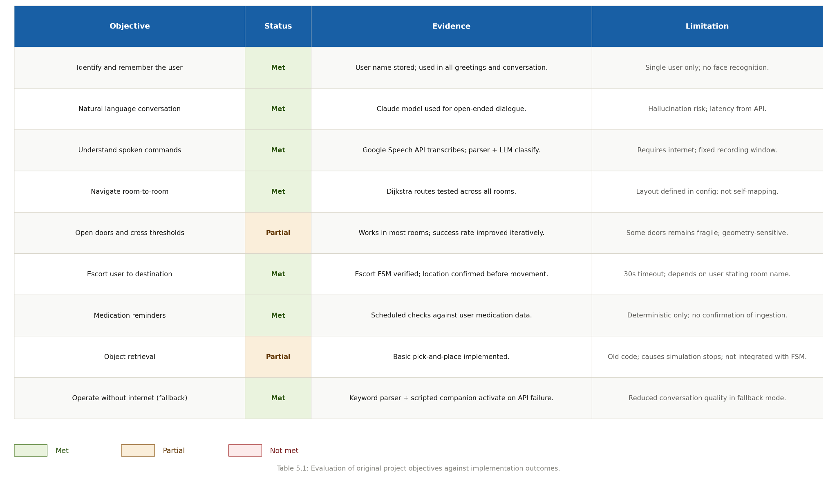

Table 6.1 Requirements success table

6.3 Contribution of the Project
So the challenge isn't about how well each component can operate, but how to bring it all together gracefully. Most helper robot technologies today are very specialized (either responding to voice commands or providing tactile reassurance) and aren't capable of managing multiple concurrent skills, or performing them in conjunction.
From here, the system will develop a goal of integrating sophisticated conversational and dependable navigation. Systems of this sort would make robots more adaptable as well as safer. Demonstrating AI adaptability and keeping enough reliability for a system to establish and maintain a dependable connection with the less mobile population are an essential goal.

6.4 Critical Reflection
While the appearance was sleek, a lot of the underlying problems were hidden away. The design process was rough and it really showed them a few things. Physically integrating an AI and objects was an interdisciplinary problem and there was uncertainty as to what issues to expect. The primary problem with moving through doors was something that needed to be overcome. While the AI can move through doors, the individuals will have to precisely align the doorway which was incredibly difficult for people. As a result many errors and hours spent redesigning was a frequent event. To overcome such issues, they use "trial-and-error" and simulations of the environment. Ultimately they built a hierarchical structure,

6.5 Societal Impact and Future Relevance
The population change shows how crucial technology is to seniors and also the chronic need for caregivers. Aids are necessary to assist in everyday tasks, socialization and communication thus prolonging independence. Robotic systems are there to assist people and not to substitute, while they usually carry out the less significant tasks. As such humans and robots can coexist and collaborate.

6.6 Future Work
Since the latest version of Webots is not as easy to get robots through doorways it is creating problems that might affect the real world applications too. For the sake of connecting the simulation to the real world, our system would require skills that our system does not have. Our systems are not doing as well with real worlds as we are with the virtual world. Our robots are functional, but the systems have to be able to perceive their environment, be able to "see" the world and find object and hand manipulation and paths without being in the way of any objects. All the while the systems must constantly keep up their virtual internal model with the real world environment.
This is a rather broad area of development and improving robot long term memory could be beneficial by giving reason to develop and foster relationships with robots rather than merely collecting data and by providing alternative avenues of interaction, like speech recognition and touch sensors, through which data can be received and outputted. These extensions would be valuable to all users in a system by making conversing feel more human like between bots and users, making navigating easier, and offering increased practicality in countless other tasks. Furthermore it would allow for increased human-bot collaboration in situations such as within homes and healthcare settings and eventually provide earlier detection of health and safety hazards like falling and the introduction of other such risks to implement necessary intervention.
One of the major avenues that systems would take into the real world would be for robots to physically affect their environments. As robots rely on controllers now to operate door handles it would be highly ideal for them to be capable of doing so as a means of manipulation that all would expect of a robot in time. Eventually the robot would not only move to draw handles and cupboards but be able to identify them and then move items to draw handles and cupboards which would necessitate improved manipulation of the arm and hand and an understanding of sensing as well. Another issue to be worked out is determining how much force is to be applied to certain situations.

6.7 Concluding Reflection
This solution doesn't necessarily solve all the problems faced by elderly caring. But it shows us the large impact and possibilities which could be brought by the smart robots and the artificial intelligence. We are able to supply robotic system that is humanized and at the same time it can take effect. Intelligence leads safety and the safety leads intelligence. It's a win win case between the elderly and the AI robot carer.

References
- World Health Organization (WHO), "Ageing: Global Population — Questions and Answers," WHO News Room, 2025. Available: https://www.who.int/news-room/questions-and-answers/item/population-ageing
- United Nations, "Ageing: Global Issues," United Nations Department of Economic and Social Affairs, 2024. Available: https://www.un.org/en/global-issues/ageing
- Khan, H. T. A., et al., "Public Health Challenges and Responses to the Growing Ageing Populations," Public Health Challenges, Wiley Online Library, 2024. DOI: 10.1002/puh2.213
- OECD, "Is Care Affordable for Older People?," OECD Health Policy Studies, OECD Publishing, Paris, 2024. DOI: 10.1787/450ea778-en
- World Economic Forum, "Elderly Care: How Can Countries Cope with Ageing Populations?," WEF Reports, August 2023. Available: https://www.weforum.org/stories/2023/08/elderly-social-care-dementia-villages/
- University of Minnesota, "Autonomy and Dignity for Elderly Using Socially Assistive Technologies," IEEE/RSJ IROS Workshop on Assistive Robots, 2023. Available: https://www-users.cse.umn.edu/~gini/publications/papers/iros23-assistive.pdf
- United Nations Population Fund (UNFPA), "Ageing Population Projections," UNFPA Global Issues, 2024. Available: https://www.unfpa.org/ageing
- Bulletin of the World Health Organization, "Health System Responses to Population Declines," Bulletin of the World Health Organization, 2025. PMC11865851
- Springer Nature Link, "Assistive Robots in Older Adult Care: A Systematic Review and Prospects," In: Clinical Gerontology, 47(5), 909–921, 2024. Available: https://link.springer.com/chapter/10.1007/978-3-031-92710-2_12
- Coşar, S., et al., "ENRICHME: Perception and Interaction of an Assistive Robot for the Elderly at Home," International Journal of Social Robotics, 12, 779–805, 2020. DOI: 10.1007/s12369-019-00614-y
- de la Puente, P., et al., "Editorial: Assistive and Service Robots for Health and Home Applications (RH3)," Frontiers in Neurorobotics, 2024. DOI: 10.3389/fnbot.2024.1503038. PMC11554614
- Trainum, K., Liu, J., Hauser, E., Xie, B., "Nursing Staff's Perspectives of Care Robots for Assisted Living Facilities: Systematic Literature Review," JMIR Aging, 7, e58629, 2024. DOI: 10.2196/58629
- JMIR Aging, "Social Robots and Sensors for Enhanced Aging at Home: Mixed Methods Study with a Focus on Mobility and Socioeconomic Factors," JMIR Aging, 7, e63092, 2024. DOI: 10.2196/63092
- PMC — Integrative Review, "Care Robots for Community-Dwelling Older Adults: An Integrative Review," PMC, 2025. PMC12640725. Databases: PubMed, CINAHL, Cochrane.
- Kachouie, R., et al., "Socially Assistive Robots in Elderly Care: A Mixed-Method Systematic Literature Review," International Journal of Human-Computer Interaction, 30, 369–393, 2014. DOI: 10.1080/10447318.2013.873278
- Frontiers in Robotics and AI, "Assimilation of Socially Assistive Robots by Older Adults: An Interplay of Uses, Constraints and Outcomes," Frontiers in Robotics and AI, vol. 11, 2024. DOI: 10.3389/frobt.2024.1337380
- Frontiers in Robotics and AI, "Considerations for Designing Socially Assistive Robots for Older Adults," Frontiers in Robotics and AI, 2025. DOI: 10.3389/frobt.2025.1622206
- Abdollahi, H., et al., "Artificial Emotional Intelligence in Socially Assistive Robots for Older Adults: A Pilot Study," IEEE Transactions on Affective Computing, 14(3), 2020–2032, 2023.
- Boada, J. P., Maestre, B. R., Genís, C. T., "The Ethical Issues of Social Assistive Robotics: A Critical Literature Review," Technology in Society, 67, 2021. DOI: 10.1016/j.techsoc.2021.101726
- PMC, "Older Adults' Communication with an Interactive Humanoid Robot: Expectations and Experiences in Verbal and Nonverbal Communication," PMC, 2024. PMC11315771. Mixed methods study, Germany.
- Kim, C. Y., Lee, C. P., Mutlu, B., "Understanding Large-Language Model (LLM)-Powered Human-Robot Interaction," In: Proceedings of the 2024 ACM/IEEE International Conference on Human-Robot Interaction, pp. 371–380, 2024.
- PMC, "Human-Robot Interaction and Social Robot: The Emerging Field of Healthcare Robotics and Perspectives for Spinal Care," PMC, 2024. PMC11456931.
- Zhang, C., Chen, J., Li, J., et al., "Large Language Models for Human-Robot Interaction: A Review," Biomimetic Intelligence and Robotics, 3, 100131, 2023.
- Touvron, H., et al., "LLaMA: Open and Efficient Foundation Language Models," arXiv preprint, arXiv:2302.13971, 2023.
- Huang, L., et al., "A Survey on Hallucination in Large Language Models: Principles, Taxonomy, Challenges, and Open Questions," ACM Transactions on Information Systems, 1(1), Article 1, 2024. DOI: 10.1145/3703155. arXiv:2311.05232
- Cluster Computing, "The Rise of Hallucination in Large Language Models: Systematic Reviews, Performance Analysis and Challenges," Cluster Computing, Springer, 2025. DOI: 10.1007/s10586-025-05891-z
- Xue, Z., Elksnis, A., Wang, N., "Integrating Large Language Models for Intuitive Robot Navigation," Frontiers in Robotics and AI, 2025. DOI: 10.3389/frobt.2025.1627937. PMC12444764
- Pascual Espada, J., et al., "Leveraging Large Language Models for Autonomous Robotic Mapping and Navigation," International Journal of Advanced Robotic Systems, SAGE, 2025. DOI: 10.1177/17298806251325965
- Ahn, M., Brohan, A., Brown, N., et al., "Do As I Can, Not As I Say: Grounding Language in Robotic Affordances," arXiv preprint, arXiv:2204.01691, 2022.
- Singh, I., et al., "ProgPrompt: Generating Situated Robot Task Plans Using Large Language Models," In: 2023 IEEE International Conference on Robotics and Automation (ICRA), pp. 11523–11530. DOI: 10.1109/ICRA48891.2023.10161317
- PMC, "Robot Navigation Based on Potential Field and Gradient Obtained by Bilinear Interpolation and a Grid-Based Search," PMC, 2022. PMC9102480.
- Liu, Y., et al., "Path Planning for Smart Car Based on Dijkstra Algorithm and Dynamic Window Approach," Wireless Communications and Mobile Computing, Wiley, 2021. DOI: 10.1155/2021/8881684
- AIP Publishing, "Path Planning of Indoor Mobile Robot Based on Improved A* Algorithm Incorporating RRT and JPS," AIP Advances, 13(4), 045313, 2023. DOI: 10.1063/5.0142451
- Fadzli, S. A., Abdulkadir, S. I., et al., "Robotic Indoor Path Planning Using Dijkstra's Algorithm with Multi-Layer Dictionaries," IEEE Conference Publication, IEEE Xplore, 2015. DOI: 10.1109/ICIAS.2015.7371031
- PMC, "Path Planning of a Mobile Delivery Robot Operating in a Multi-Story Building Based on a Predefined Navigation Tree," PMC, 2023. PMC10648392. Dijkstra-based room graph approach.
- Scientific Reports (Nature), "Semantic Orientation for Indoor Navigation System Using Large Language Models," Scientific Reports, 2025. DOI: 10.1038/s41598-025-25281-0
- Wada, K., Shibata, T., "The Benefits of and Barriers to Using a Social Robot PARO in Care Settings: A Scoping Review," BMC Geriatrics, 19, 2019. DOI: 10.1186/s12877-019-1244-6
- Lu, L. C., et al., "Effectiveness of Companion Robot Care for Dementia: A Systematic Review and Meta-analysis," Innovations in Aging, 5(2), 2021.
- Robinson, H., et al., "Therapeutic Robots for Older Adults: Investigating the Potential of PARO," ResearchGate, 2014. Available: https://www.researchgate.net/publication/262393516
- ACM DL, "Employing Socially Assistive Robots in Elderly Care," ACM Digital Library, 2022. DOI: 10.1145/3511047.3537687
- Michel, O., "Cyberbotics Ltd. Webots™: Professional Mobile Robot Simulation," International Journal of Advanced Robotic Systems, 1(1), 39–42, 2004. DOI: 10.5772/5618
- Yue, L., et al., "Simulation for Senior Undergraduate Education of Robot Engineering Based on Webots," Computer Applications in Engineering Education, Wiley, 2021. DOI: 10.1002/cae.22377
- ScienceDirect, "Bridging the Reality Gap Between the Webots Simulator and e-puck Robots," Robotics and Autonomous Systems, Elsevier, 2014. DOI: 10.1016/j.robot.2014.01.001
- arXiv, "Simulation-Based Control Architecture Using Webots and Simulink," arXiv preprint, arXiv:2505.02081, 2025.
- Chevalier, P., et al., "10 Years of Human-NAO Interaction Research: A Scoping Review," Frontiers in Robotics and AI, 2021. DOI: 10.3389/frobt.2021.744526. PMC8640132
- Pino, O., Palestra, G., Trevino, R., De Carolis, B., "The Humanoid Robot NAO as Trainer in a Memory Program for Elderly People with Mild Cognitive Impairment," International Journal of Social Robotics, pp. 21–33, 2020.
- Heer, R. J., et al., "Can a Humanoid Social Robot Stimulate the Interactivity of Cognitively Impaired Elderly? A Study Based on Computer Vision Methods," The Visual Computer, Springer Nature, 2021. DOI: 10.1007/s00371-021-02242-y
- PMC, "Navigating Autonomy, Privacy, and Ageism in Robot Home Care with Aged Users: A Preliminary Analysis of ROB-IN," PMC, 2025. PMC12053780. Ethics-of-care framework.
- Scerri, A., et al., "Ethical Issues Associated with Assistive Technologies for Persons Living with Dementia and Their Caregivers – An Overview of Reviews," Dementia, SAGE, 2025. DOI: 10.1177/14713012251341374
- ResearchGate, "Ethical Challenges of Assistive Robotics in Elderly Care: Review and Reflection," ResearchGate, October 2022. Seven moral dimensions: autonomy, justice, privacy, etc.
- ScienceDirect, "Tensions and Antagonistic Interactions of Risks and Ethics of Using Robotics and Autonomous Systems in Long-Term Care," Technological Forecasting and Social Change, Elsevier, 2021. DOI: 10.1016/j.techfore.2021.120529
- Juhasova, B., Juhas, M., Halenar, I., and Borkin, D., "TCP/IP Protocol Utilisation in Process of Dynamic Control of Robotic Cell According to Industry 4.0 Concept," IFAC-PapersOnLine, 50(1), 5859-5864, 2017. DOI: 10.1016/j.ifacol.2017.08.1132
- "Event-Driven Industrial Robot Control Architecture for the Adept V+ Platform," PMC, 2021. PMC7924425. Available: https://www.ncbi.nlm.nih.gov/pmc/articles/PMC7924425/
- Tagliabue, A., et al., "Towards a Hybrid LLM/Model-Based Architecture for Robot Coaching," CEUR Workshop Proceedings, vol. 4101, paper 6, 2023. Available: https://ceur-ws.org/Vol-4101/paper6.pdf
- Su, H., et al., "Adaptation of a Robotic Dialog System for Medication Reminder in Elderly Care," Smart Health, 26, 100330, 2022. DOI: 10.1016/j.smhl.2022.100330
- Liang, A., et al., "Medication Adherence Management for In-Home Geriatric Care with a Companion Robot and a Wearable Device," Smart Health, 30, 100428, 2023. DOI: 10.1016/j.smhl.2023.100428
- Lin, W. C., et al., "Building a Speech Recognition System with Privacy Identification Based on Google Voice for Social Robots," Journal of Supercomputing, 78, 15060-15088, 2022. DOI: 10.1007/s11227-022-04487-3
- "Voice Interaction Recognition Design in Real-Life Scenario Mobile Robot Applications," Applied Sciences, 13(5), 3359, 2023. DOI: 10.3390/app13053359
- Karoui, O., et al., "Autonomous Navigation and Real-Time Mapping Using Ultrasonic Sensors in NAO Humanoid Robot," Engineering, Technology & Applied Science Research, 12(5), 9199-9204, 2022. DOI: 10.48084/etasr.5180
- Chen, W., et al., "A Robot Architecture of Hierarchical Finite State Machine for Autonomous Mobile Manipulator," in Intelligent Robotics and Applications, LNCS vol. 10463, Springer, Cham, 2017. DOI: 10.1007/978-3-319-65298-6_39
- Foukarakis, M., Leonidis, A., Antona, M., and Stephanidis, C., "Combining Finite State Machine and Decision-Making Tools for Adaptable Robot Behavior," in Universal Access in Human-Computer Interaction: Aging and Assistive Environments, LNCS vol. 8515, Springer, Cham, 2014. DOI: 10.1007/978-3-319-07446-7_60
- Collett, T. H. J., MacDonald, B. A., and Gerkey, B. P., "A Modular System Architecture for Autonomous Robots Based on Blackboard and Publish-Subscribe Mechanisms," in Proc. IEEE International Conference on Robotics and Automation (ICRA), 2005.
- "A Survey of Safety Control for Service Robots," Robotics and Autonomous Systems, 182, 104829, 2024. DOI: 10.1016/j.robot.2024.104829
- Le Goues, C., et al., "Software Engineering for Robotics: Future Research Directions," arXiv preprint arXiv:2401.12317, 2024.
- Chukwurah, K. N., et al., "Sim-to-Real Transfer in Robotics: Addressing the Gap between Simulation and Real-World Performance," ResearchGate preprint, 2024.
- Tobin, J., et al., "Sim-to-Real Transfer of Robotic Control with Dynamics Randomization," arXiv preprint arXiv:1710.06537, 2017.
- Luo, C., Yuan, R., Mao, B., Liu, Q., Wang, W., and He, Y., "Technology Acceptance of Socially Assistive Robots Among Older Adults and the Factors Influencing It: A Meta-Analysis," The Gerontologist, 2024. DOI: 10.1177/07334648231202669
- Fiorini, L., et al., "Robotic Services Acceptance in Smart Environments with Older Adults: User Satisfaction and Acceptability Study," JMIR mHealth and uHealth, 6(11), e11203, 2018. DOI: 10.2196/11203
- Henschel, A., et al., "Technology Acceptance in Socially Assistive Robots: Scoping Review of Models, Measurement, and Influencing Factors," JMIR Human Factors, 2022. DOI: 10.2196/37860
- "A Systematic Review of Safety-Driven Approaches in Human-Robot Collaborative Systems," Sensors, 26(7), 2079, 2026. DOI: 10.3390/s26072079
- Wei, C., Xu, J., Wang, C., Wiggers, P., and Hindriks, K., "An Approach to Navigation for the Humanoid Robot Nao in Domestic Environments," in Towards Autonomous Robotic Systems (TAROS), LNCS vol. 8069, Springer, Berlin, 2014. DOI: 10.1007/978-3-662-43645-5_33
- "When a Notification at the Right Time Is Not Enough: The Reminding Process for Socially Assistive Robots in Institutional Care," Frontiers in Robotics and AI, 11, article 1369438, 2024. DOI: 10.3389/frobt.2024.1369438
- "Co-Design Methodology for Rapid Prototyping of Modular Robots in Care Settings," Frontiers in Robotics and AI, 12, article 1581506, 2025. DOI: 10.3389/frobt.2025.1581506
- Fuertes, J., et al., "Architecture for Integration of Robots and Sensors for the Care of the Elderly," Robotics, 8(3), 76, 2019. DOI: 10.3390/robotics8030076
- Hendrich, N., Bistry, H., and Zhang, J., "Architecture and Software Design for a Service Robot in an Elderly-Care Scenario," Engineering, 1(1), 27-35, 2015. DOI: 10.15302/J-ENG-2015007
- Boniardi, F., et al., "A Door-to-Door Path-Finding Approach for Indoor Navigation," ISPRS Annals of the Photogrammetry, Remote Sensing and Spatial Information Sciences, 2019. DOI: 10.5194/isprs-annals-IV-2-W5-45-2019
- Colledanchise, M., and Ogren, P., "Comparison between Behavior Trees and Finite State Machines," arXiv preprint arXiv:2405.16137, 2024.
- "Social Robots to Attend Elderly People: A Survey," Applied Sciences, 14(12), 5287, 2024. DOI: 10.3390/app14125287
- "ROS Navigation Stack: Architectures, Methods, and Trends," PMC, 2025. PMC12300016.

Appendix A: Command Reference
The robot is operated by speaking or typing in ordinary language; a deterministic parser removes filler words such as "please" or "could you" before the request is interpreted. The commands it recognises are listed below.

list places - the robot names the rooms it knows.

go to <room> - the robot navigates to the named room, opening any doors along the route.

guide me to <room> - the robot first confirms where the user is, then escorts them to the destination.

open the <label> door / close the <label> door - the robot commands the named door to open or close.

reset (or restart) - the robot restarts the session and re-acquires the user's name.

Appendix B: House Topology Configuration
The home is not hard-coded. It is described in a configuration file (hierarchical_config.json) that the planner reads at start-up. Each room records its centre, its entry points (door coordinates), its bounding box, and its type, while the hallways array lists the weighted connections between rooms that Dijkstra's algorithm searches. Re-targeting the robot to a different house is therefore a matter of editing this file. A representative excerpt follows.

Room entry (corridor)

"corridor": {

"center": [-0.36, -0.32],

"entry_points": [[0.5, -0.32], [-1.5, -0.32], [1.84, 0.88],

[1.84, -1.52], [-2.36, 0.88], [-2.36, -1.52]],

"bounds": [-4.71, 3.99, -1.27, 0.63],

"type": "hallway", "size": [9.4, 2.3]

}
Weighted room graph and navigation targets

"hallways": [["corridor","kitchen",1.5], ["corridor","living_room",1.5],

["corridor","bedroom",1.5], ["corridor","bathroom",1.5]]

"room_targets": kitchen, living_room, bedroom, bathroom

Appendix C: Illustrative Code Excerpts
The following short excerpts illustrate the parts of the implementation most relevant to the discussion. They are trimmed for readability; the complete source code is available in the project's Git repository.

C.1 Room-level path search (Dijkstra)

def dijkstra(self, start_room, goal_room):

pq = [(0, start_room, [start_room])] # (cost, room, path)

visited = set()

while pq:

cost, room, path = heapq.heappop(pq)

if room in visited:

continue

visited.add(room)

if room == goal_room:

return path # lowest-cost room sequence

for neighbor, edge_cost in self.edges(room):

if neighbor not in visited:

heapq.heappush(pq, (cost + edge_cost,

neighbor, path + [neighbor]))

C.2 Sonar-based forward-motion gating

def is_safe_to_advance(self, min_clearance=0.35):

if not self._enabled:

return True

left = self._left.getValue()

right = self._right.getValue()

# safe if EITHER side is clear, so a one-sided door

# frame does not trigger a false stop

return left >= min_clearance or right >= min_clearance

Appendix D: Development Milestones
The system was built incrementally rather than from a single finished design. The following phases mark its main stages of development.
Phase 1 - Environment and platform: the Webots simulation, the NAO robot and its controller, and a Supervisor able to read the doors' state and position.
Phase 2 - Communication infrastructure: the TCP link to the external voice process, and speech-to-text turning spoken input into commands.
Phase 3 - Conversational AI: the deterministic command parser and the full companion able to converse and remember the user.
Phase 4 - Assistive logic: the escort and task state machine, with dialogue-first confirmation of the user's location.
Phase 5 - Navigation and control: replacing the early grid scheme with the hierarchical room-level planner, and introducing the RobotBrain state machine (understanding, planning, execution, monitoring).
Phase 6 - Iterative debugging: repeated cycles of running scenarios in simulation, diagnosing failures (especially at doorways), and refining the executor.

